Spring Boot Notes (in28minutes)

Spring Framework:

* Spring framework is used to develop a large variety of applications
* Spring framework provides the 2 main features to build easily maintainable applications: dependency injection and autowiring
* Spring framework allows you to use less lines of code and spring boot further reduces coding effort to build java enterprise applications
* 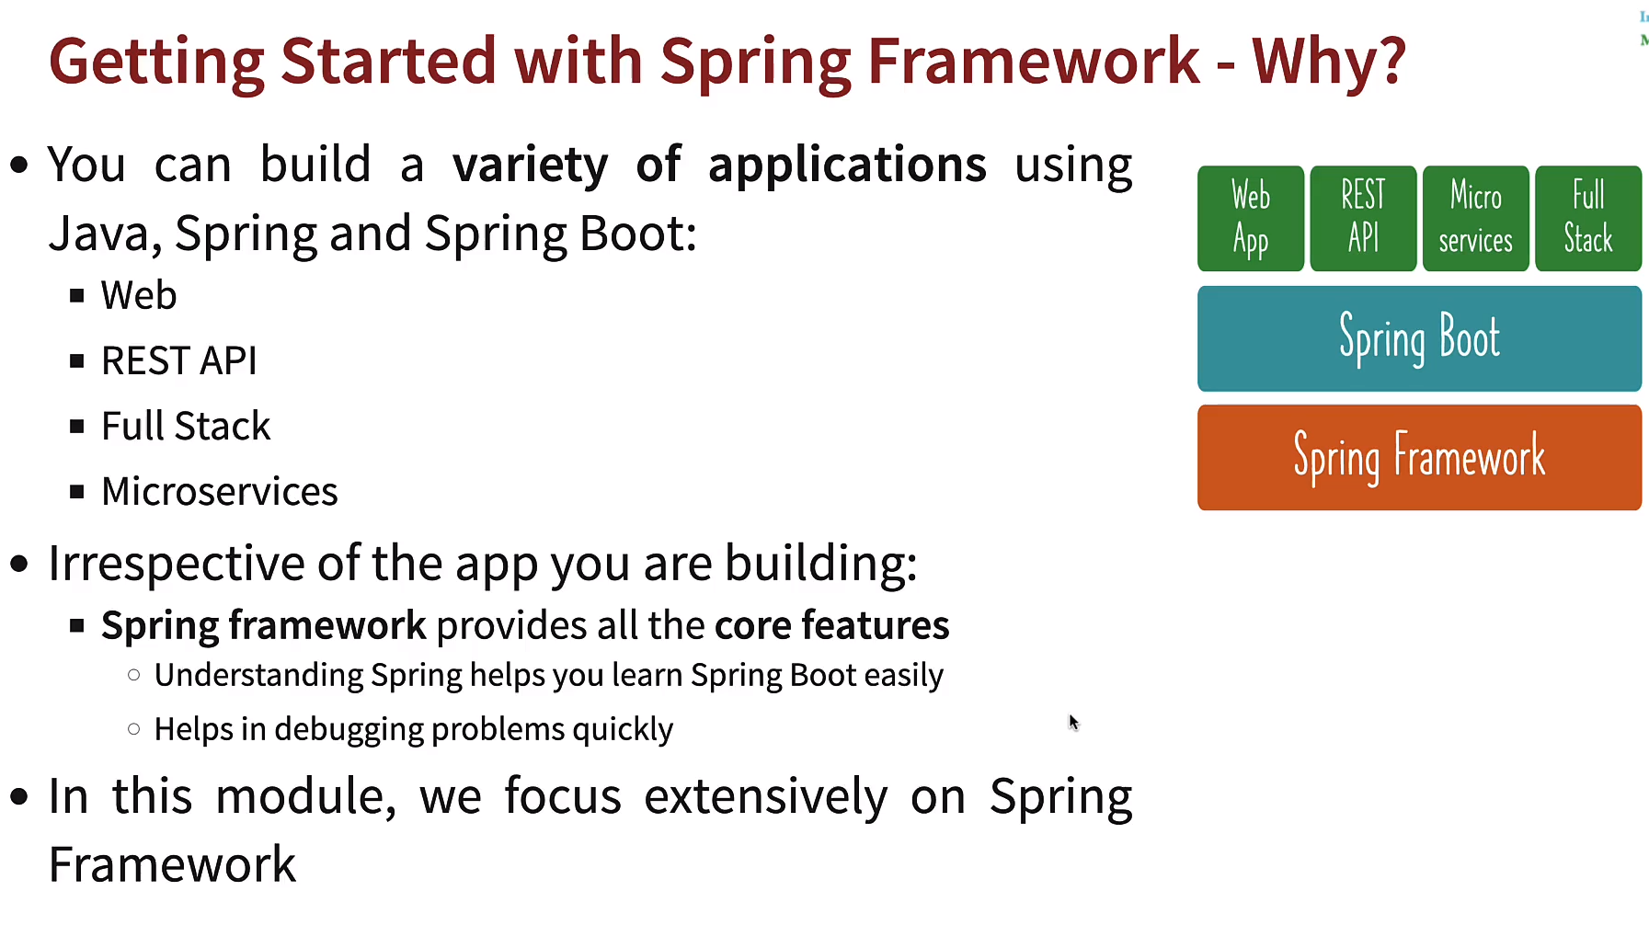
* To create a spring project, go to spring.start.io website
* Do not use snapshot versions (as they are currently under development)
* Group is similar to package name and artifact is similar to class name
* Src folder contains all the source code , resources folder contains all the configuration and test folder contains all the test cases
* Tight coupling means your class is specifically using another class object (in the constructor), so, in order to use another class object, you have remove earlier one and replace it with newer one
* But with interfaces, we can achieve loose coupling. We can create an interface and make different classes implement that interface and use the interface object wherever required
* Currently we are creating our own objects, like (mariogame, supercontra game) and using them in game runner class, I.e., mario, supercontra , etc are dependencies of game runner class
* Spring allows us to create these games (as we might have 1000’s of these classes) and wires them in the game runner class
* To get spring to manage the objects: follow 2 steps:

1. launch a spring context
2. configure the things that we want spring to manage - @Configuration

* Record Person (String name, int age) {};
* Record allows us to not make getters and setters for Person class
* Beans are objects managed by spring framework
* Context.getBean(“name”) is the syntax to retrieve a bean
* To change bean name use @Bean(name = “yourbean_name”) over your method
* You can retrieve a bean by using the class name like: context.getBean(Address.class);
* Hence, to retrieve a bean , you can either use name of a bean or the type of the bean (I.e. class of the bean) like above
* You can also use existing beans to create new beans
* A spring container is the one which manages spring beans and their life cycle
* Spring context , spring container, ioc container, all refer to the same thing
* There are 2 spring containers:

1. Bean Factory: basic spring container
2. Application Context : advanced spring container with enterprise specific features .It is easy to use in web apps, used for easy internationalization

* Most applications use application context
* Any java object is a POJO (Plain Old Java Object)
* EJB (Enterprise Java Bean)
* Java Bean should have following things:

1. It should have no argument constructor
2. It should have getters and setters
3. It should implement serializable

* Spring Beans : any java object managed by spring is a spring bean
* Spring uses IOC container to manage these objects
* Context.getBeanDefinitionNames() is the method used to get all the beans
* @primary is used to resolve the bean when multiple objects (beans) with same interface exist
* If you have multiple beans of the same type (implementing same interface), use @Primary to mark the most important one
* @Primary indicates that a bean should be given preference when multiple candidates are qualified to autowire a single valued dependency
* @Qualifier(“some_name”) to use a specific bean
* <https://www.baeldung.com/spring-qualifier-annotation#:~:text=By%20using%20the%20%40Qualifier%20annotation,bean%20needs%20to%20be%20injected.&text=By%20including%20the%20%40Qualifier%20annotation%2C%20together%20with%20the%20name%20of,beans%20of%20the%20same%20type.>
* @Primary: A bean should be given preferance when multiple candidates are qualified
* @Qualifier: A specific bean should be auto-wired (name of the bean can be used as qualifier)
* @Component allows spring to create an instance of that class , so, that way we don’t manually need to create instances ourselves
* We need to tell our configuration class where to find that component
* So, we use @ComponentScan(“package_name of your component class”)
* 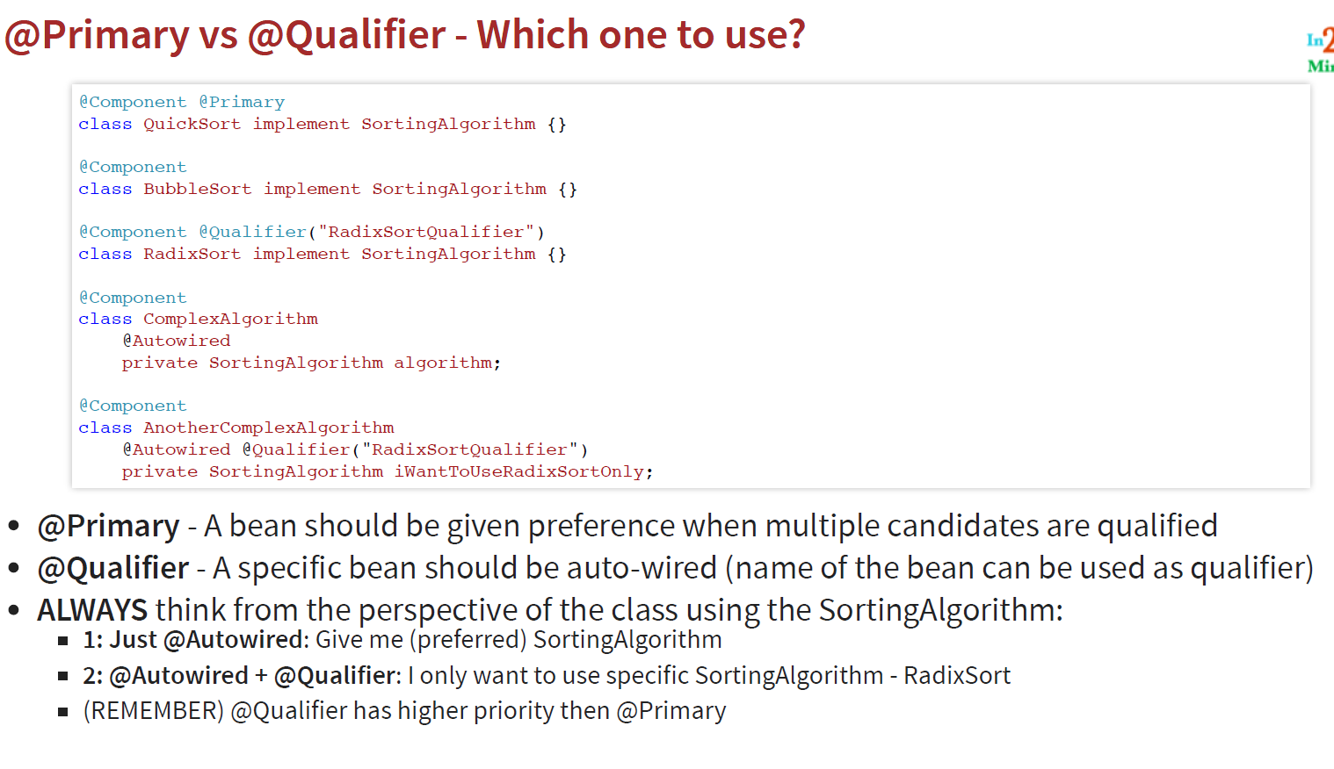
* We can also use name of the bean as qualifier
* Dependency Injection: Identify beans, their dependencies and wire them together (provides IOC - Inversion of Control)
* Its called IOC because the spring framework is creating and managing objects and not the developer, hence the control is not with the developer
* There are 3 types of dependency injection:

1. Constructor based: Dependencies are set by creating the Bean using its constructor
2. Setter based: Dependencies are set by calling setter methods on your beans
3. Field: No setter or constructor. Dependency is injected using reflection

* @Autowired is used for field injection
* Spring team recommends Constructor-based injection as dependencies are automatically set when an object is created.
* Autowiring refers to the process of wiring in the dependencies for a spring bean
* 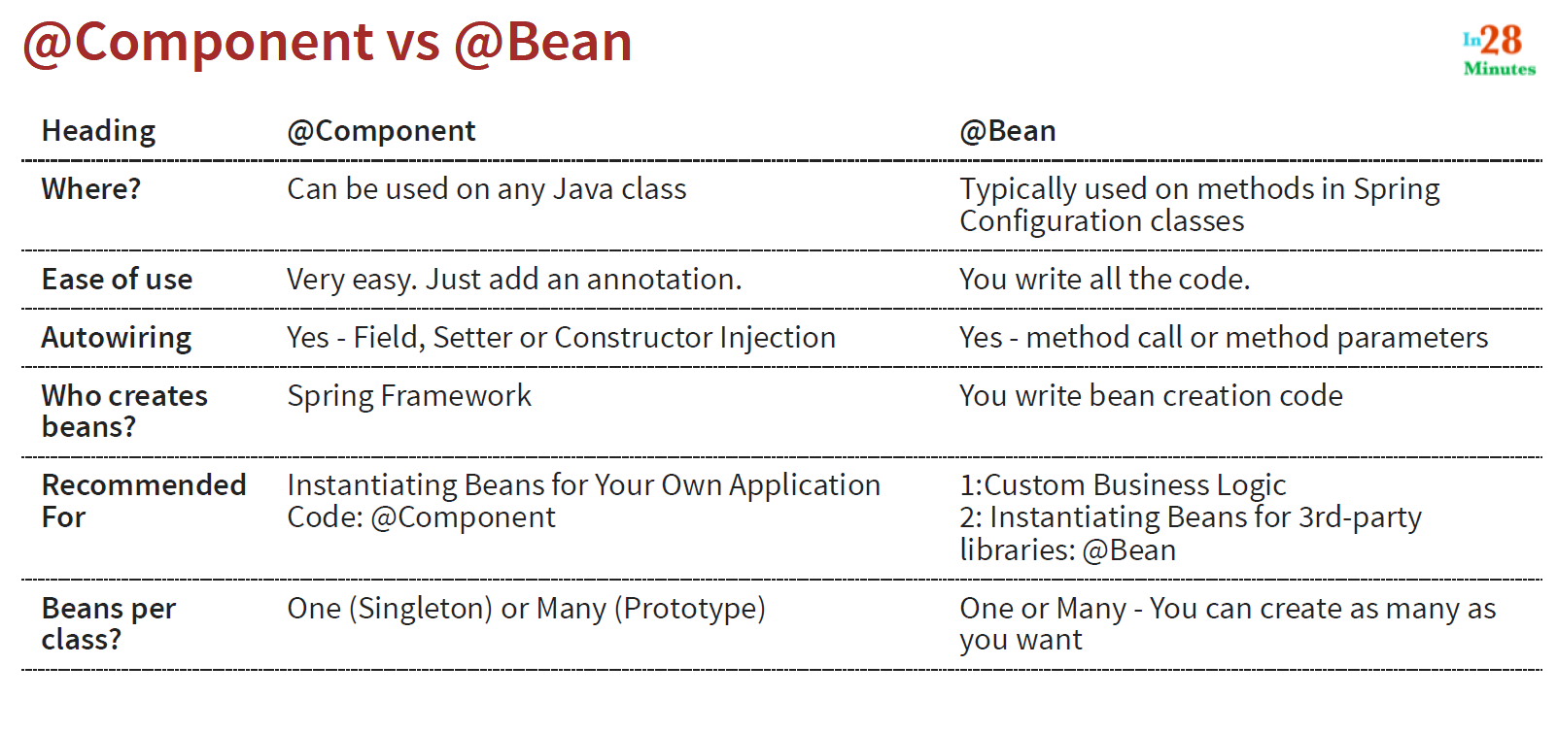
* 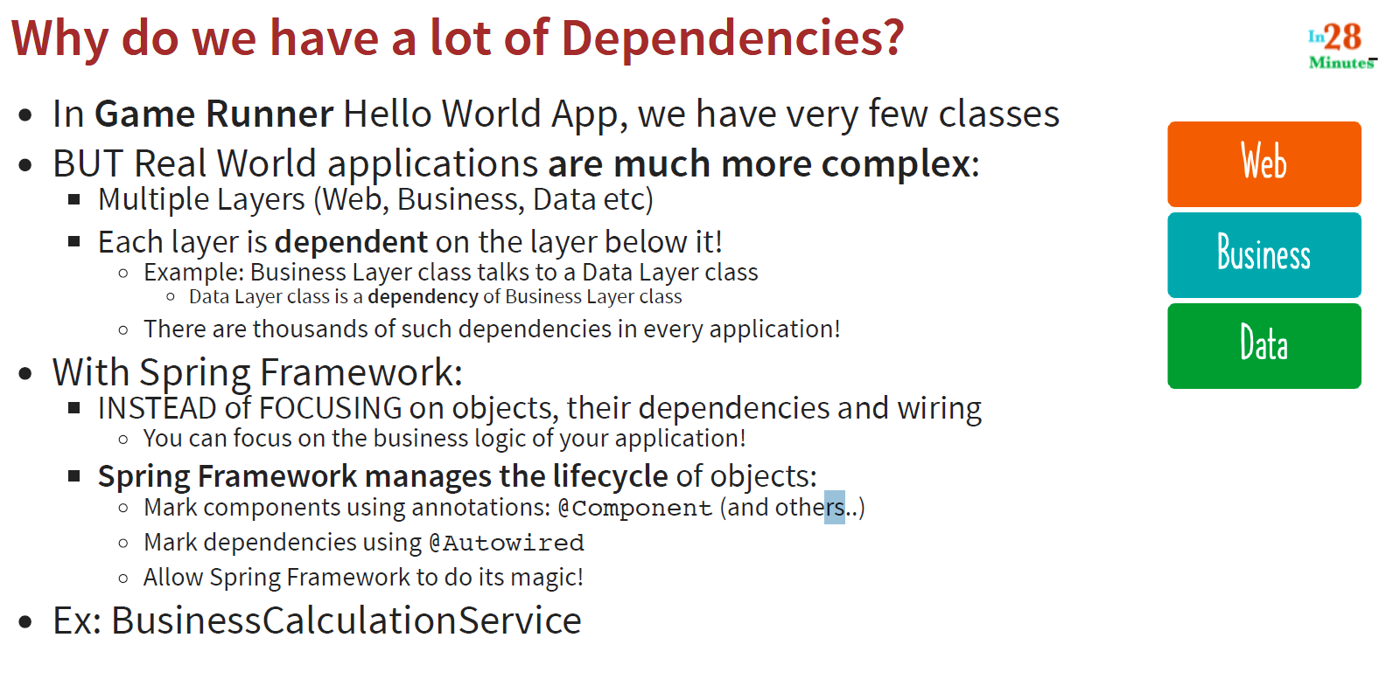
* Default initialization for spring beans is eager
* As soon as we launch the application context, the beans are initialized, called eager initialization
* To avoid this, we can use @Lazy annotation
* So, now the initialization will happen when we are making use of that bean
* 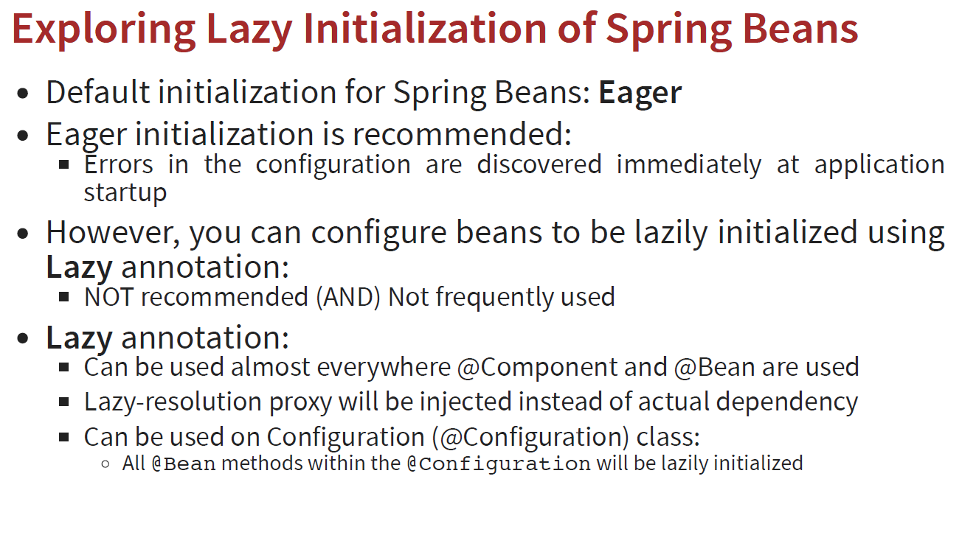
* 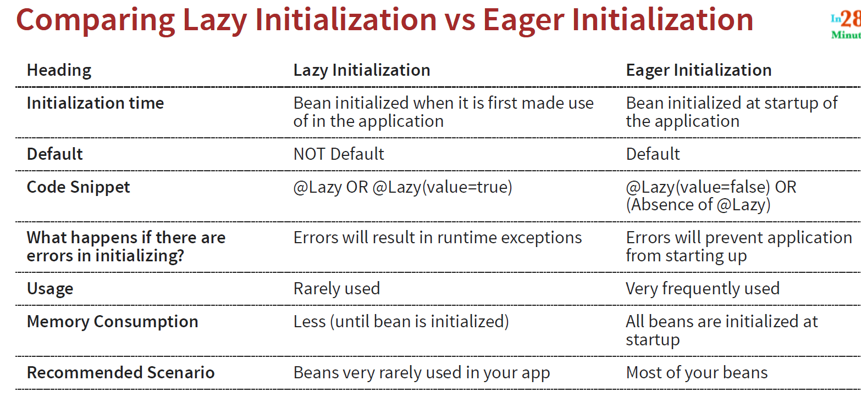
* Spring Bean Scopes:
* By default, all beans that are created in spring are singleton
* If we want different instance to be created each time a bean is referred to, we can use prototype scope by using @Scope(value=”prototype”) with any component
* 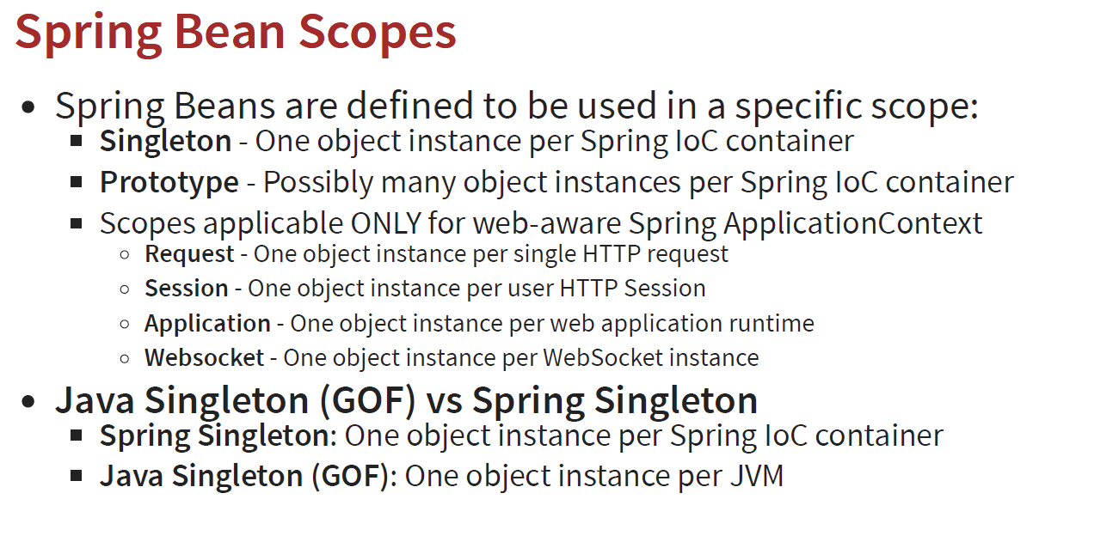
* 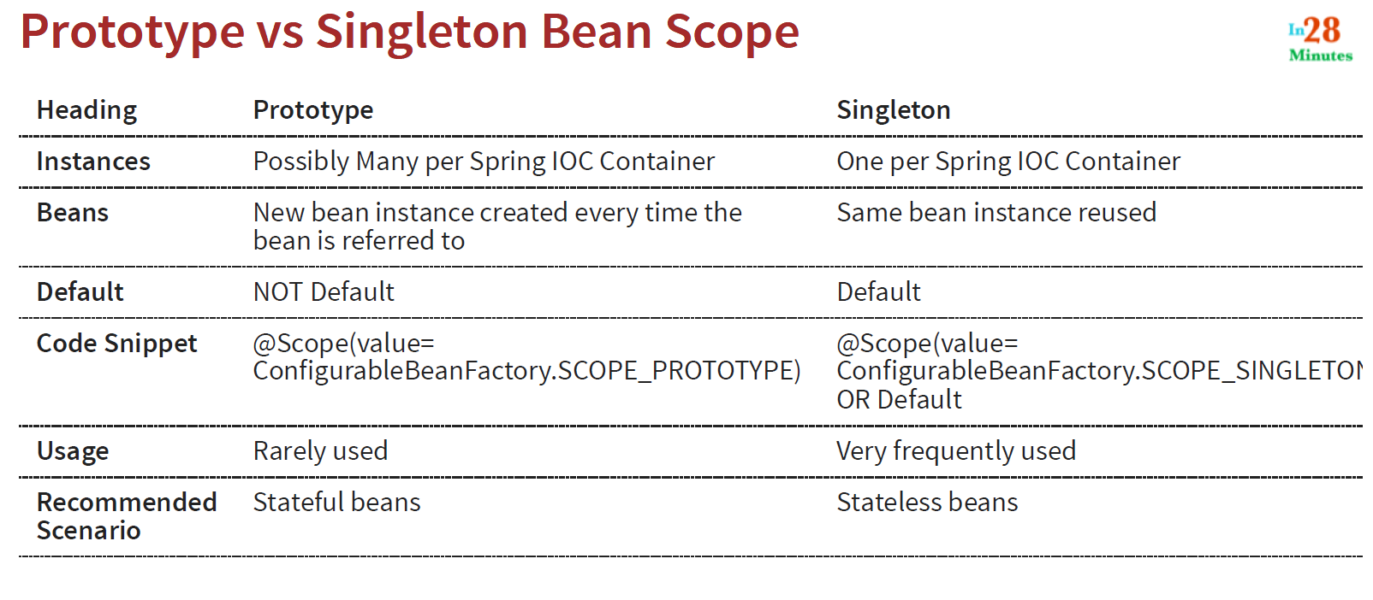
* Prototype scope is used when using information like user details, etc so, we might need different instance for each user
* @PostConstruct annotation is used on a method that needs to be executed after dependency injection is done to perform any initialization. This method must be invoked before the class is put into service
* @PreDestroy annotation is used on a method as a callback notification to signal that the instance is in the process of being removed by the container
* Java beans can also be configured in the xml file using xml and using <bean> tags
* These existed before @Bean annotations
* Earlier we used xml configurations as annotations didn’t exist
* Xml configuration is very rarely used nowadays but some older projects might still use them
* 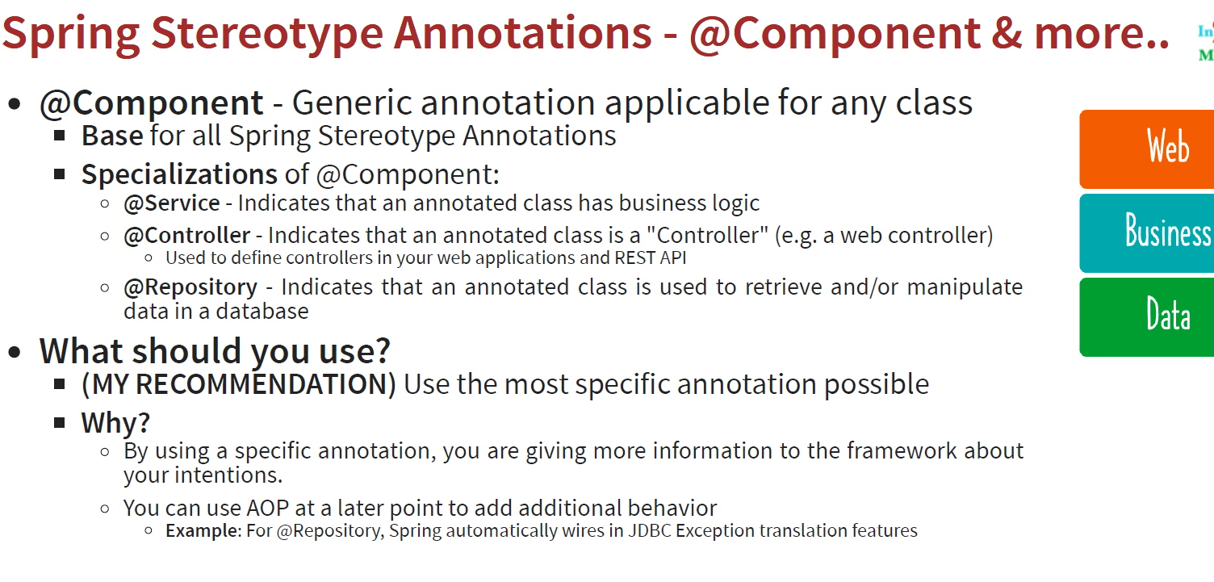
* 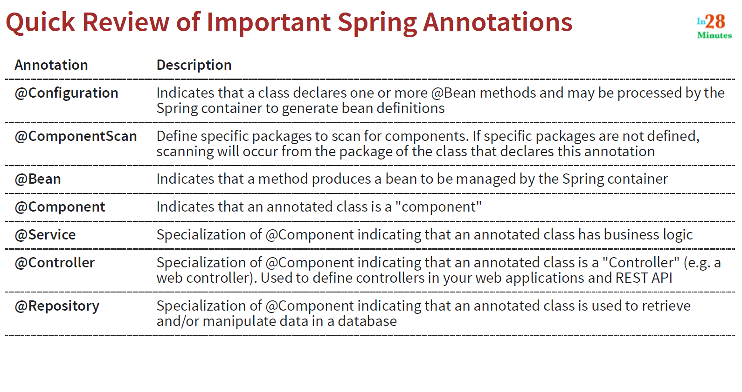
* 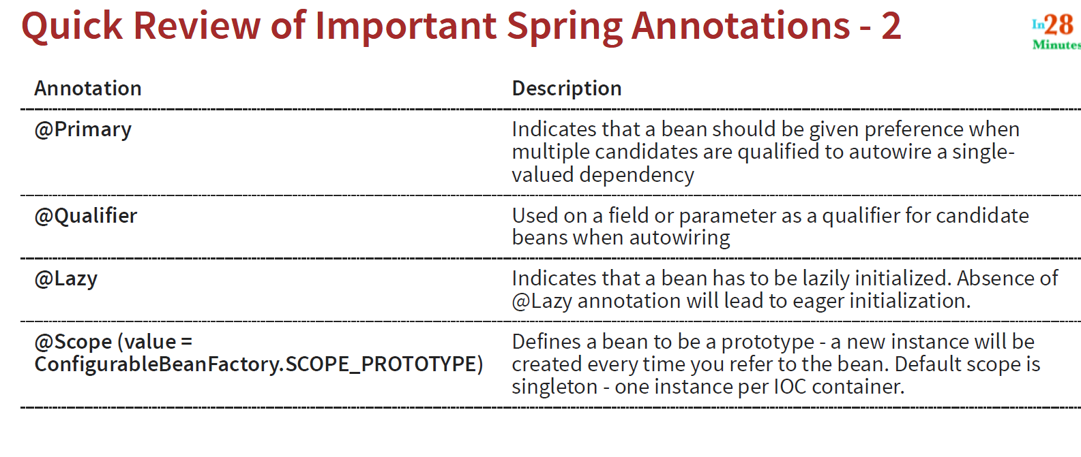
* 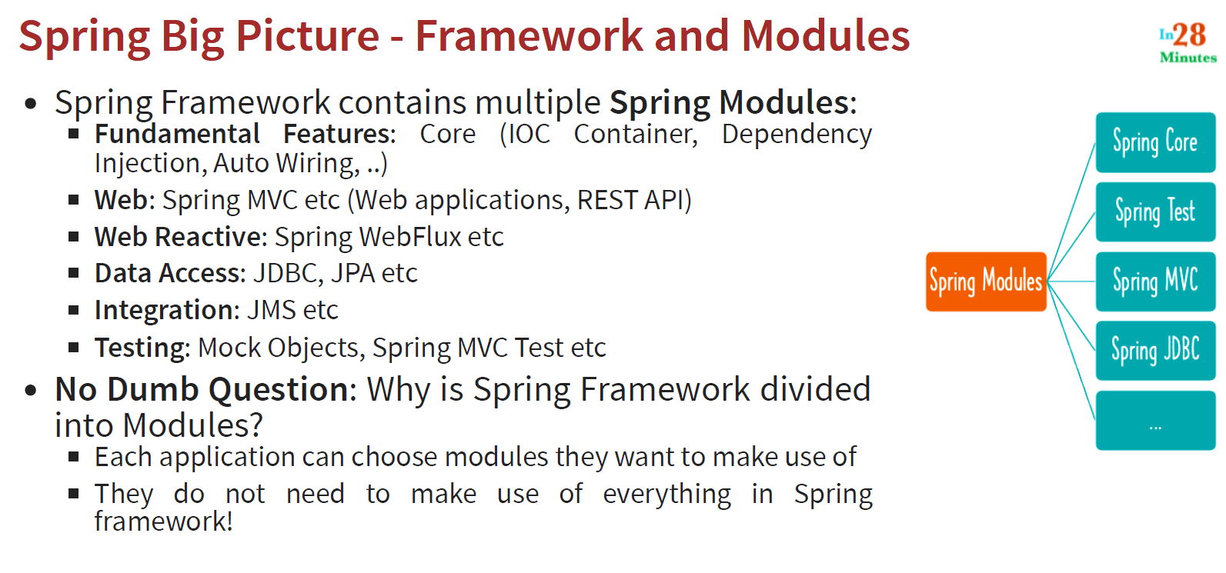
* 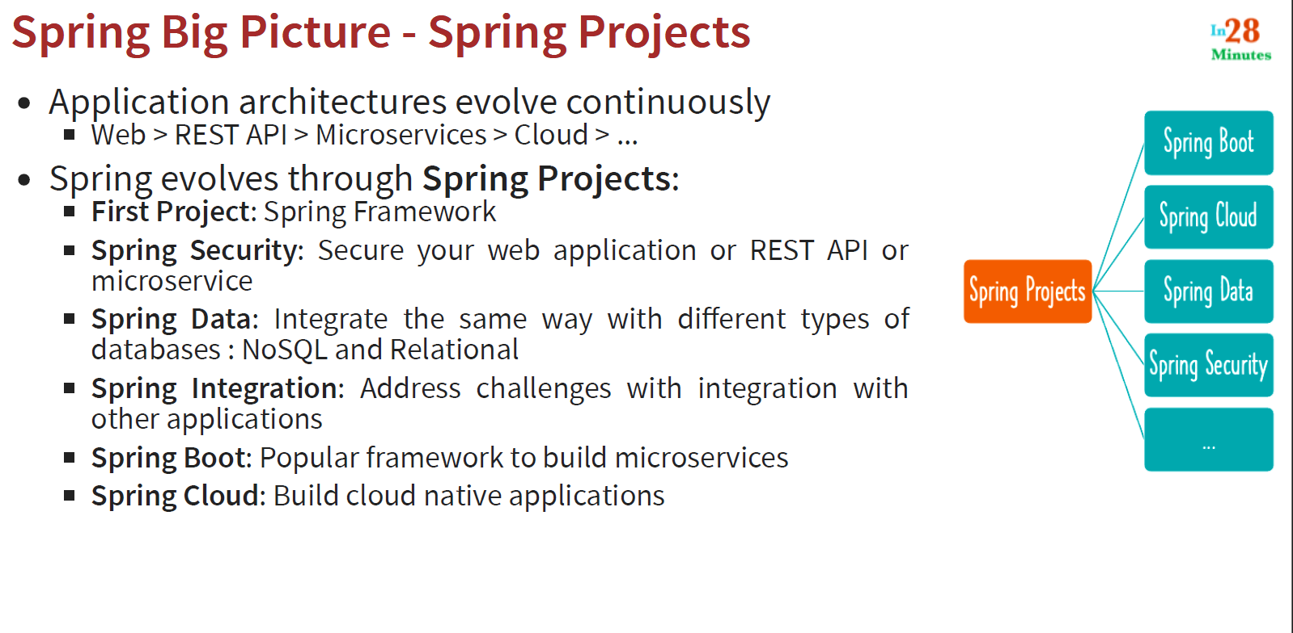
* 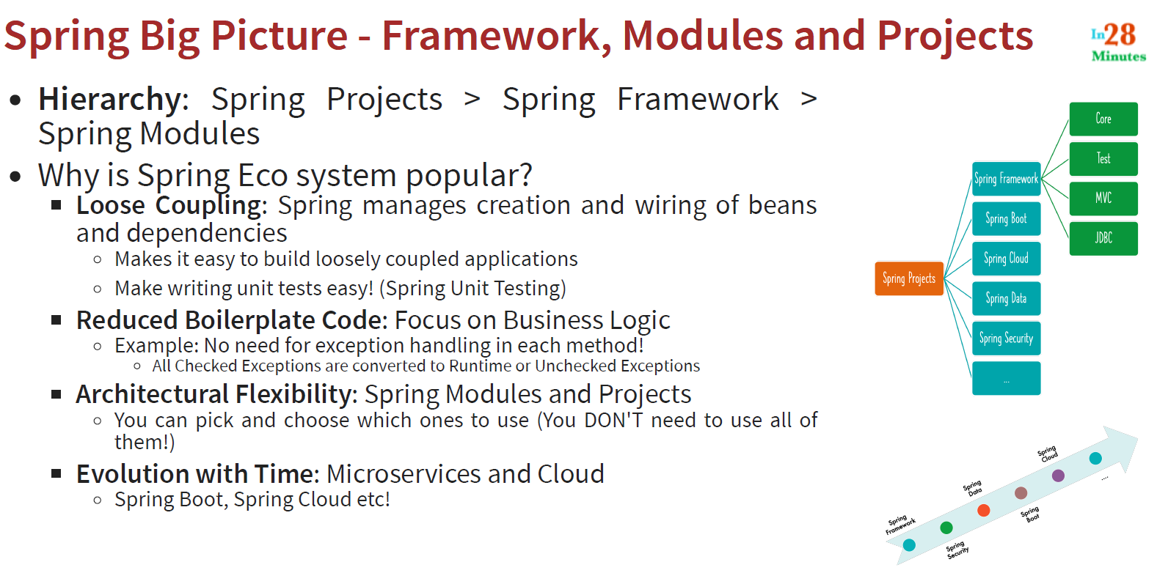

Spring Boot Framework:

* Spring Boot allows us to build production ready applications quickly
* Before Spring Boot, it was difficult to build web applications as we needed dependency management, configurations, handling NFRs(Non Functional Features) like logging, error handling, monitoring the application
* Use @RestController for defining a rest controller
* Use @RequestMapping to map a method to a specific url like: /courses
* 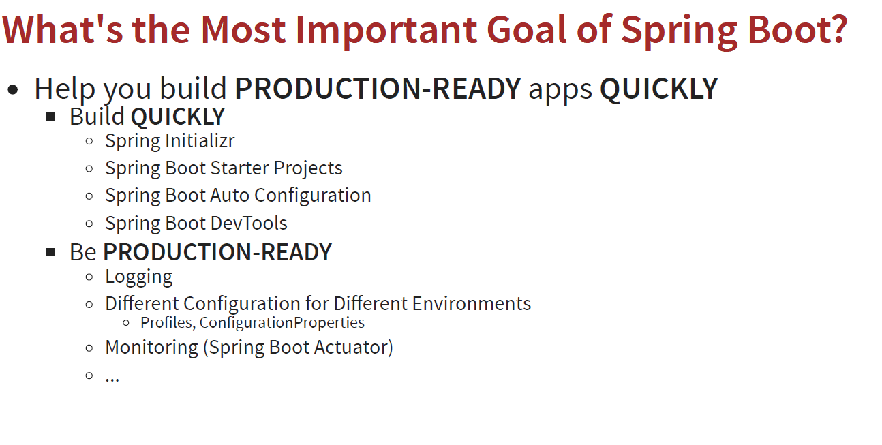
* 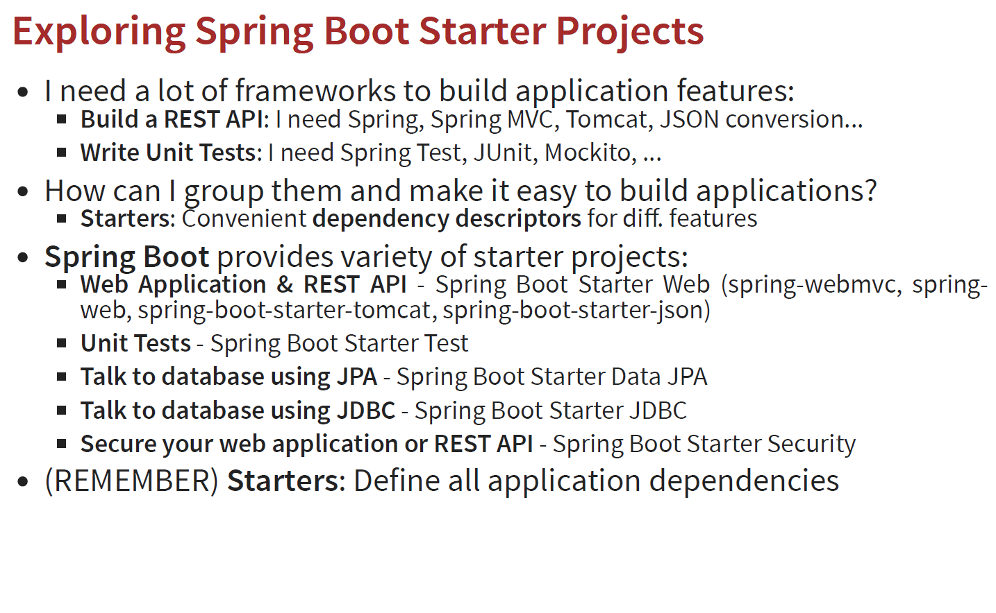
* To change logging level, type: logging.level.org.springframework=debug in application.properties file in src/main/resources
* Default logging level is info
* Auto Configuration: Spring Boot auto-configuration helps us automatically configure a Spring application based on the dependencies that are present on the classpath
* 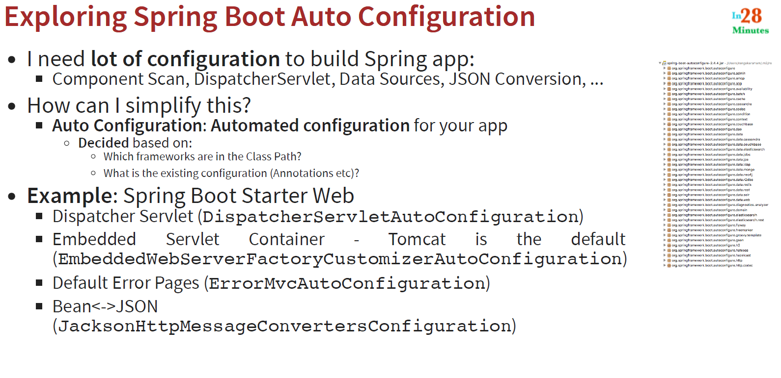
* 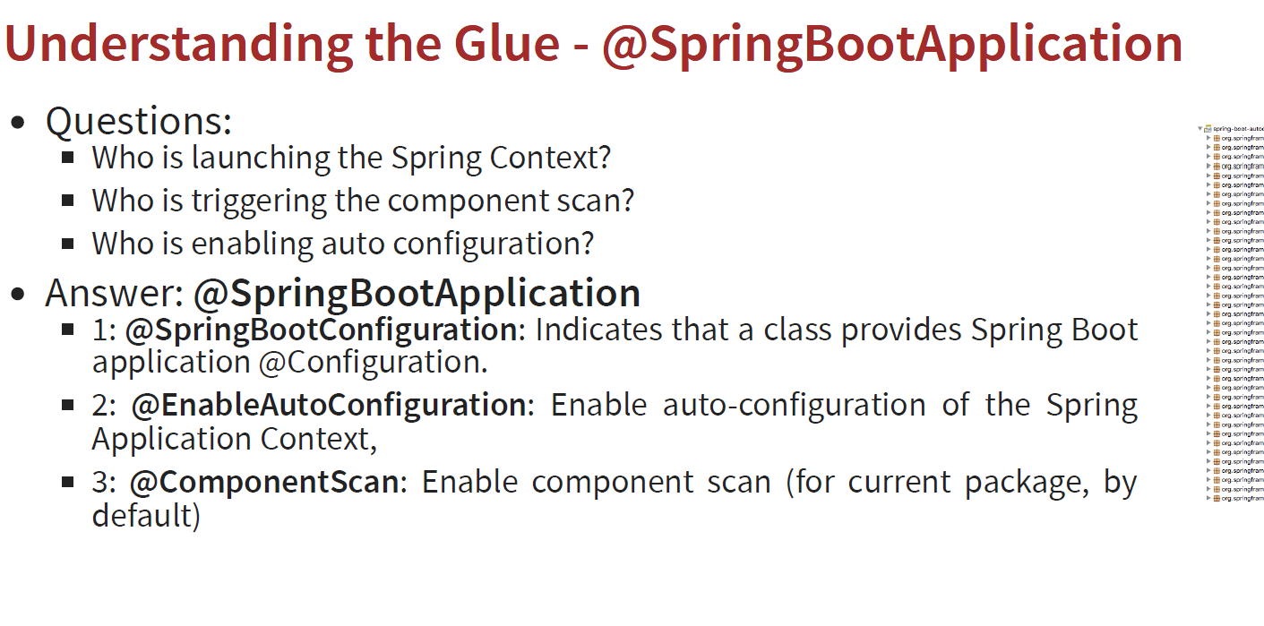
* All the logic for auto configuration is present in spring-boot-auto-configure.jar
* Using Spring boot devtools, we don’t need to restart the server each time we make change in the code and helps in developer productivity
* Just add spring-boot-devtools dependency in pom.xml
* Applications have different environments like dev, qa, prod
* Profiles helps us to provide environment specific configurations
* For this, create file like application-dev.properties and application-prod.properties and define things like logging level in these properties
* Use spring.profile.active=prod in application.properties file. This overrides the changes in application.properties file and uses the changes from application-prod.properties file
* 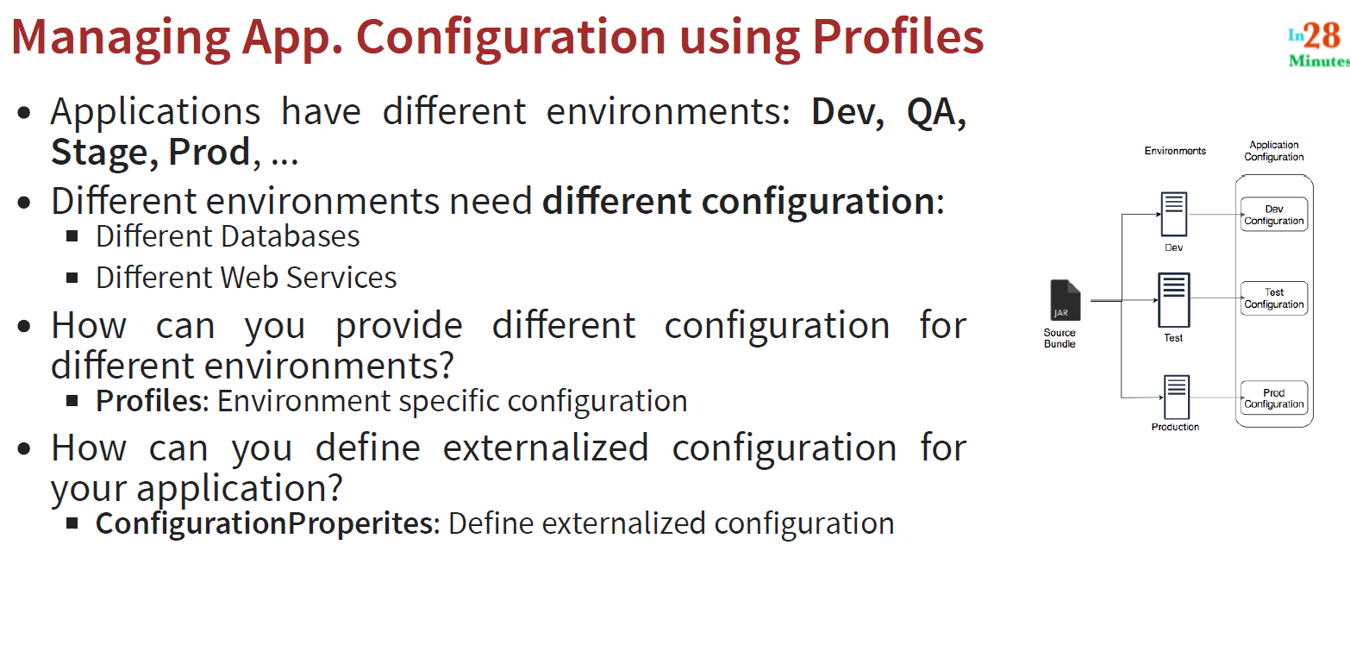
* To have more custom properties defined, we can define a separate class with @ConfigurationProperties(prefix=”currency-service”) annotation along with @Component annotation
* 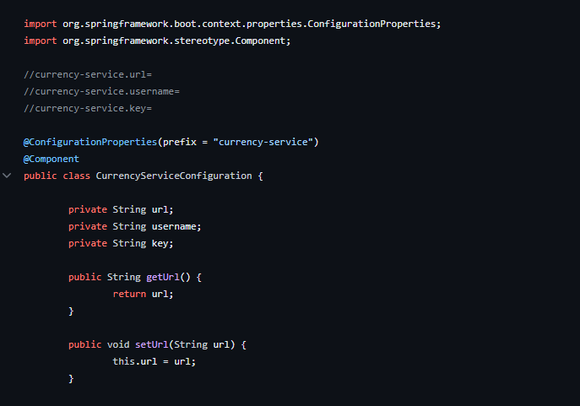
* 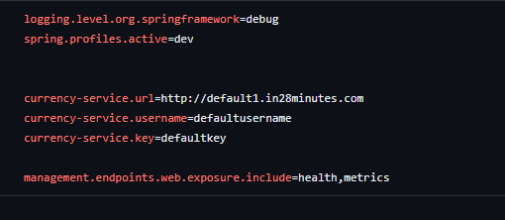
* This class acts as the centralized class for all the application related configurations
* 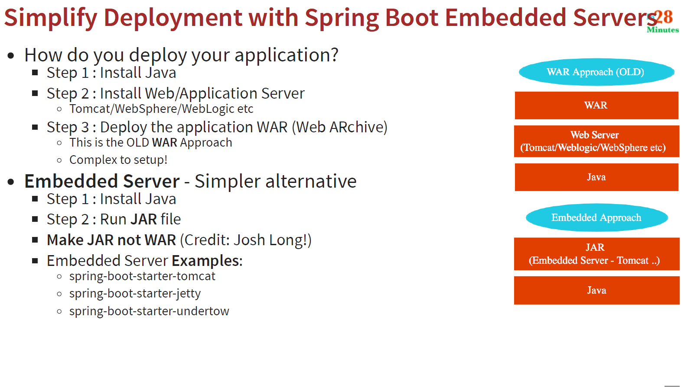
* Spring Boot actuator allows us to manage and monitor our application
* 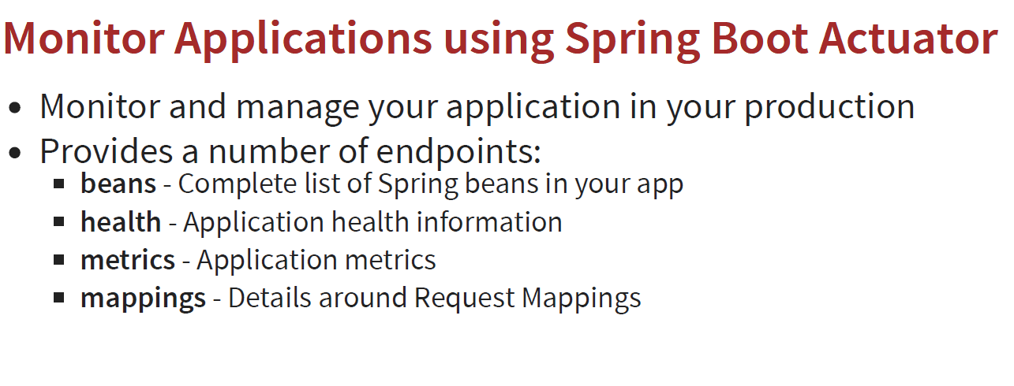
* Add management.endpoints.web.exposure.include=* to expose all the endpoints exposed by actuator
* Go to localhost:8080/actuator/ to see all the endpoints
* 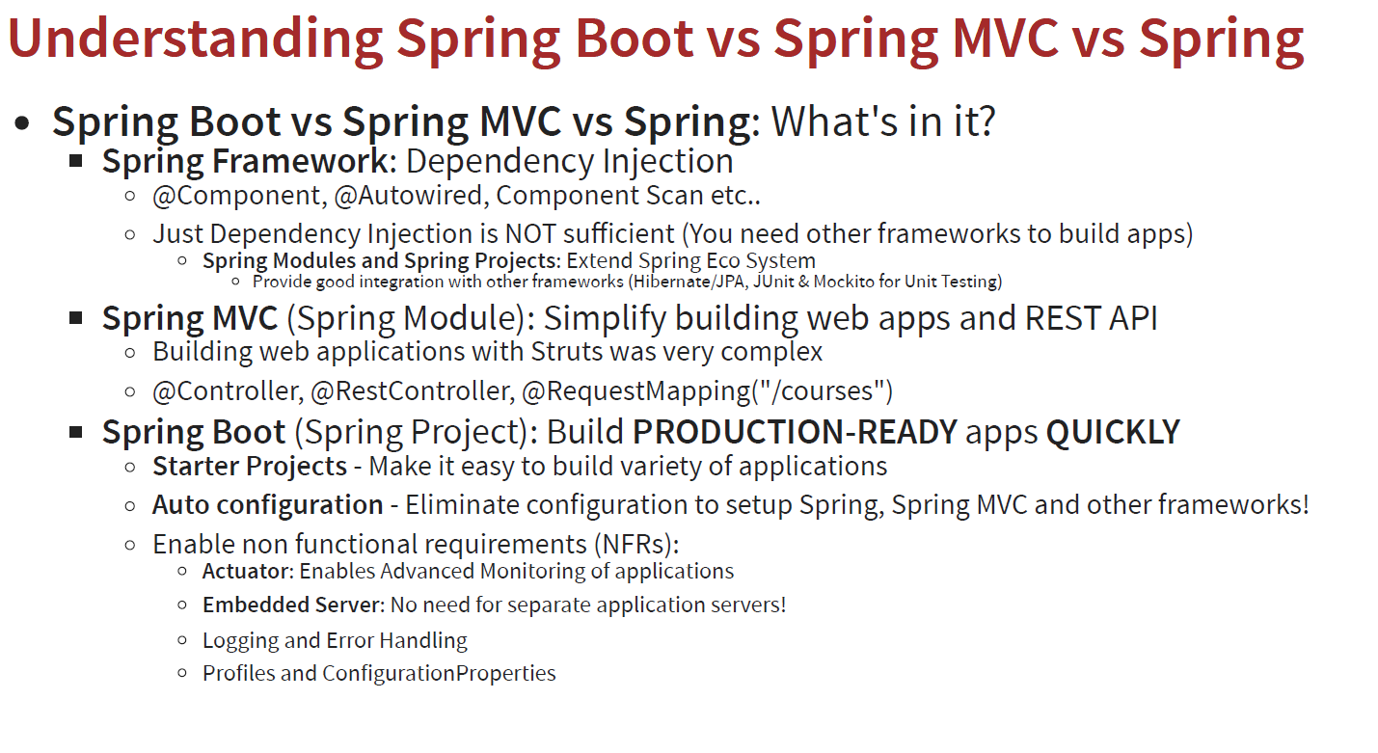
* Spring boot is a just wrapper that make it easy to use spring mvc and spring

JPA and Hibernate:

* H2 is an in-memory database
* To connect to the H2 database, go to application.properties and use spring.h2.console.enabled=true
* Take url from the logs
* Configure a static url as: spring.dd.url=jdbc:h2:mem:testdb in application.properties (this is because spring created different url each time you start the application, so to avoid this , we keep a static url )
* Create a file in resources with name “schema.sql “ and write your query to create the table and restart the application
* Spring JDBC:
* 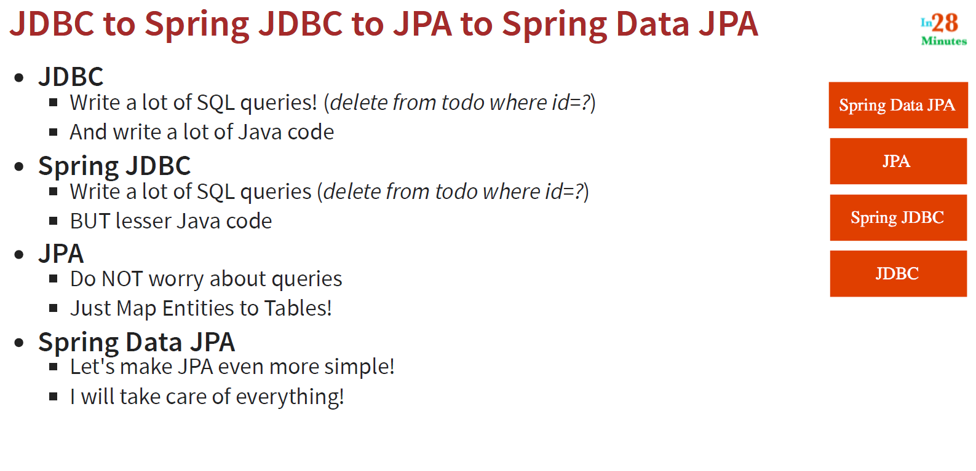
* 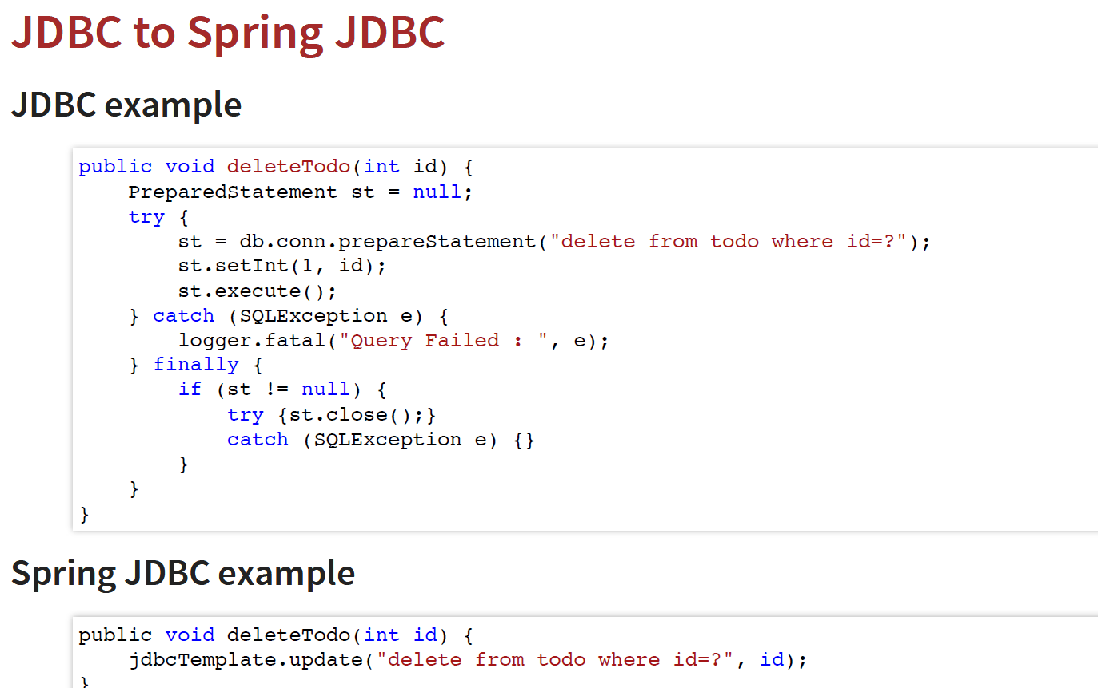
* CommandLineRunner is an interface used to indicate that a bean should run when it is contained within a spring application. It is used when we have some logic to run at the start of the application
* Row mapper interface helps us to map the query result set to the bean
* If column names and bean fields names are same, then we can use BeanPropertyRowMapper()
* JPA (Java Persistence API) helps us to map our bean directly to the table in the database
* In this case, @Entity annotation is added to the bean
* @Id is used to define primary key
* @Column(name=”your_column_name”) is used to map field name to the column in table
* No need to provide name attribute if field/table names are same as column/table names respectively
* EntityManager is used to manage our entities
* EntityManager.merge(course) is used to insert into table
* EntityManager.find(Course.class, id) to find record by id
* EntityManager.remove(course) to delete a record
* We need to add an annotation called @Transactional to the JpaRepository to perform queries with jpa
* To see sql generated by JPA, add spring.jpa.show=true to properties file
* With JPA , we don’t need to write sql queries
* JpaRepository<Course, Long> ,ie, <”entity_to_be_managed”,”data type of primary key”>
* Using Spring data jpa repository , we don’t need to make use of entity manager
* Repositorry.save() method is used to insert/update the table
* You can define your custom methods in the spring data jpa repository
* This can be done following a convention as: findByAuthor (where author is the field/column name)
* Hibernate is an implemntation of JPA
* 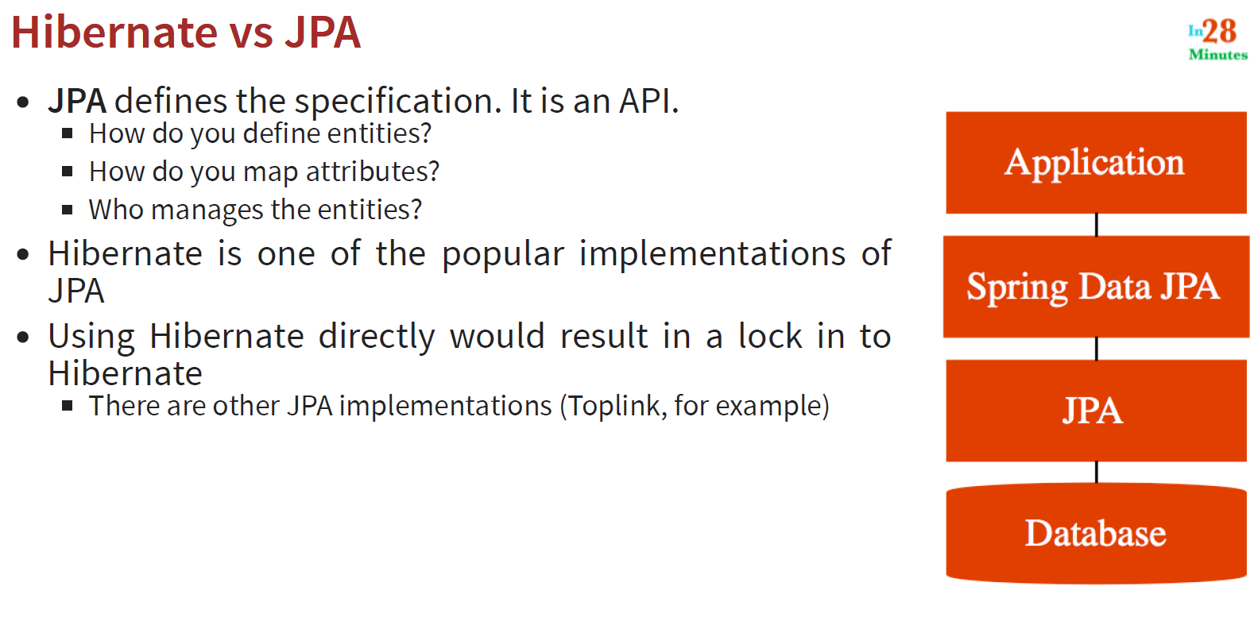

Building Java Applications: (Spring MVC)

* Pom.xml has all the dependencies for your project
* Application.properties is used to define all the configurations for your application
* @RequestMapping is used to map a url to a specific method
* @ResponseBody is used to return the string as is to the browser
* @Controller is used to tell spring that this class handles web requests
* Its difficult to return html from the spring boot applications as string
* So, we use views to resolve this
* JSP (Java Server Pages) is one of the most popular views present
* In order to use JSP, create a file called file_name.jsp in the folder /src/main/resources/META-INF/resources/WEB-INF/jsp/file_name.jsp
* Write html code in the jsp file (this is called view)
* Add spring.mvc.view.prefix=/WEB-INF/jsp/ and spring.mvc.view.suffix=.jsp in properties file to return jsp from a controller method
* You also need to add a dependency in pom.xml for jsps
* @RequestParam indicates that a method parameter should be bound to a web request parameter (used for query parameters)
* 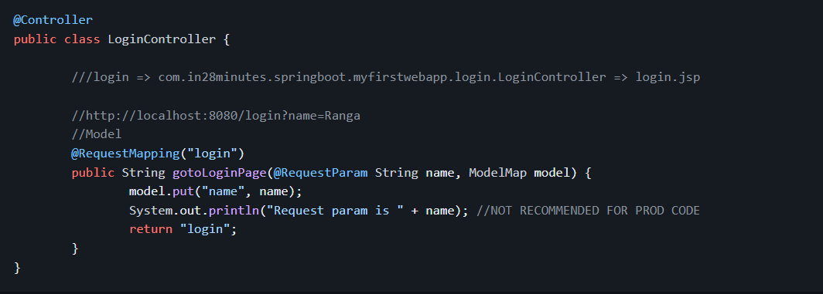
* That’s how we can get value of query parameter from web url to controller
* Now, I order to use this value I our view (jsp), we use model
* ${name} , this is how we can use this name value in jsp
* Debug level log prints a lot of lot of logs and hence might impact performance, so, in production we should use info
* You cannot use logging levels with system.out.println()
* Logging gives you more flexibility
* Default logging framework used by spring boot is logback with Sl4j
* 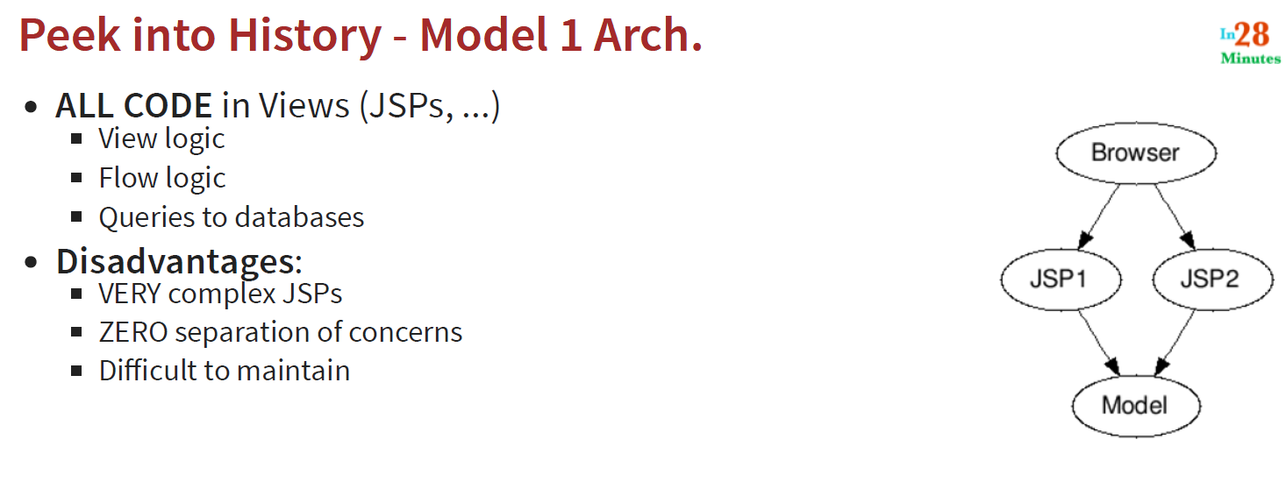
* 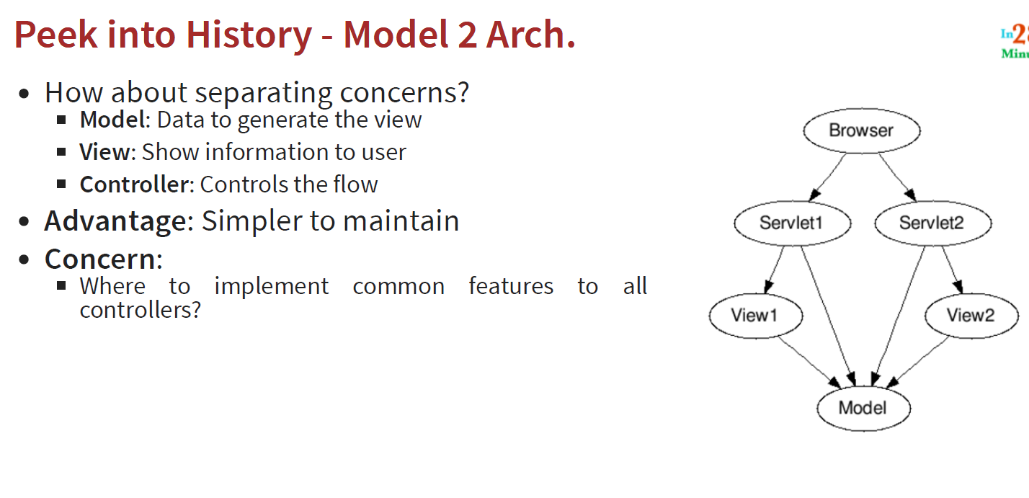
* Flow logic go into the servelets or controllers
* 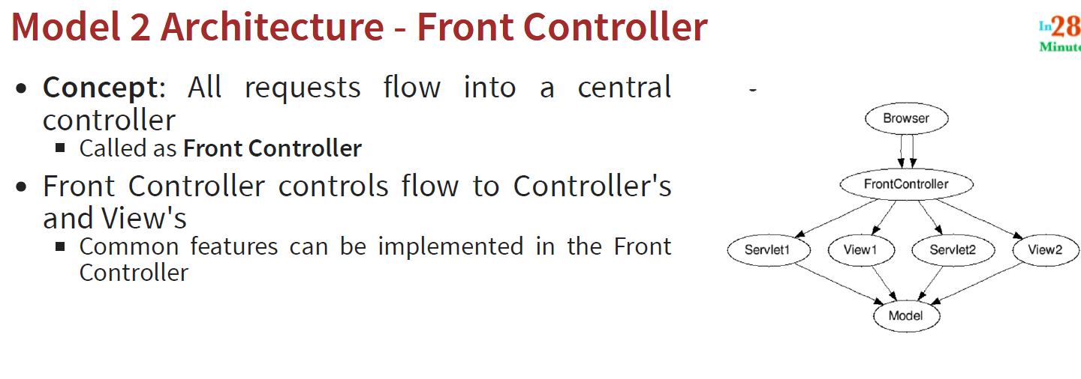
* Dispatcher Servelet is the spring mvc implementation of the model 2 front controller pattern
* 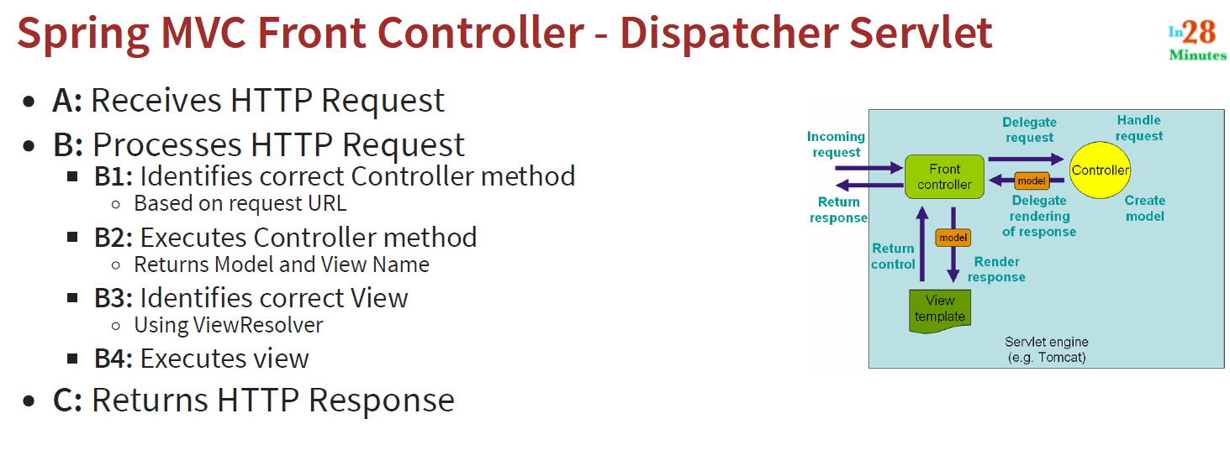
* Form data (name and password) can also be captured using @RequestParam
* When you put something in a model, by default its only available for the scope of that request
* If you want to retain values a across certain requests, you can use sessions
* This can be done by using an annotation @SessionAttributes(“name”)
* This annotation should be added in all controllers where you want to use this value
* Jstl tags are used to import dynamic values in jsp views (for using loops in html or jsp’s)
* Earlier in order to use Bootstrap, we used to download the bootstrap css file and save them in the static folder ,so, it required a lot of manual effort
* So, to automate this, we can add adependency or web jar in pom.xml
* To add validations:
* 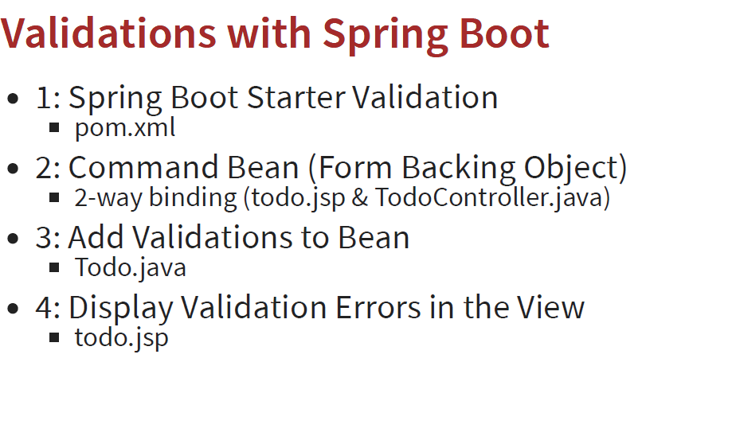
* If we have 10 request params, then our code will become complex, so, what we can do is we can directly bind the fields to the bean (todo). This is called backing object (or command bean).
* Spring security is a framework used to perform authentication
* Add a dependency in pom.xml (spring-boot-starter-security)
* All urls are protected when adding spring security
* JPA allows us to map our bean to a database table
* Whenever spring boot auto configuration sees an in memory database in the classpath, it directly creates tables for all the entities
* Create a file in resources folder called as data.sql and write your insert query to insert data inside the table
* By default, data.sql is executed before the entities, so, it will give an error of “table not found”
* To resolve this, add spring.jpa.defer-datasource-initialization=true in properties file
* Repository allows us to perform actions (CRUD operations) on our database
* Spring Data JPA automatically creates method logic for extracting data from tables. You just need to declare method like public List<Todo> findByUsername(String username); in the repository class
* In memory database means the data is lost whenever the application restarts.

Functional programming:

* With functional programming, we focus on what to do
* We convert the numbers into a stream (sequence of elements) and for each element in the stream, we specify what to do
* Stream is nothing but a sequence of elements
* Stream can only be used once
* Lambda expressions are nothing but simplified version of methods
* Optional is a container object which may or may not contain a non-null value
* So, if object of Optional class is null, it doesn’t give null pointer exception when we print this, instead it gives Optional.empty
* Lambda expressions can only be implemented via interfaces if the interface has only 1 abstract method
* Such an interface which has only 1 abstract method is called functional interface
* You can also use @FunctionalInterface annotation with the interface you are creating to be used by lambda (although this is not necessary)
* Behind the scenes, lambdas use anonymous inner classes

REST API’s in using Spring and Spring Boot:

* @RestController is the annotation used for adding a controller
* With @RestController you don’t need to add @ResponseBody to return a string back
* @Getmapping is used to handle get requests
* In the background , all requests are going to the dispatcher servlet (front controller pattern)
* Dispatcher servlet is mapped to the root url (“/”)
* Dispatcher servlet then passes the request to appropriate controller
* 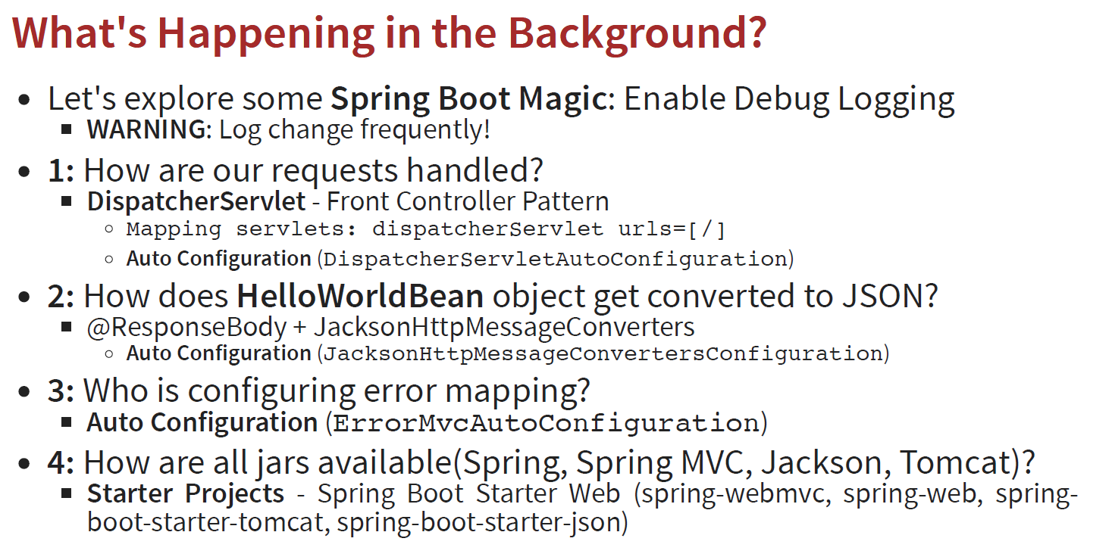
* Path parameters are used to access variables from url
* @Pathvariable is used to capture path variables
* 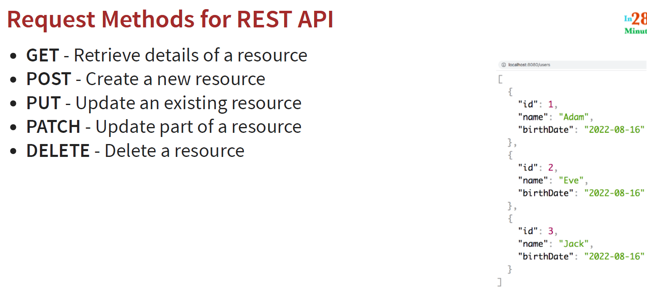
* @RequestBody is used for indicating that a method parameter is bound to the body of a web request (usually used in post requests)
* 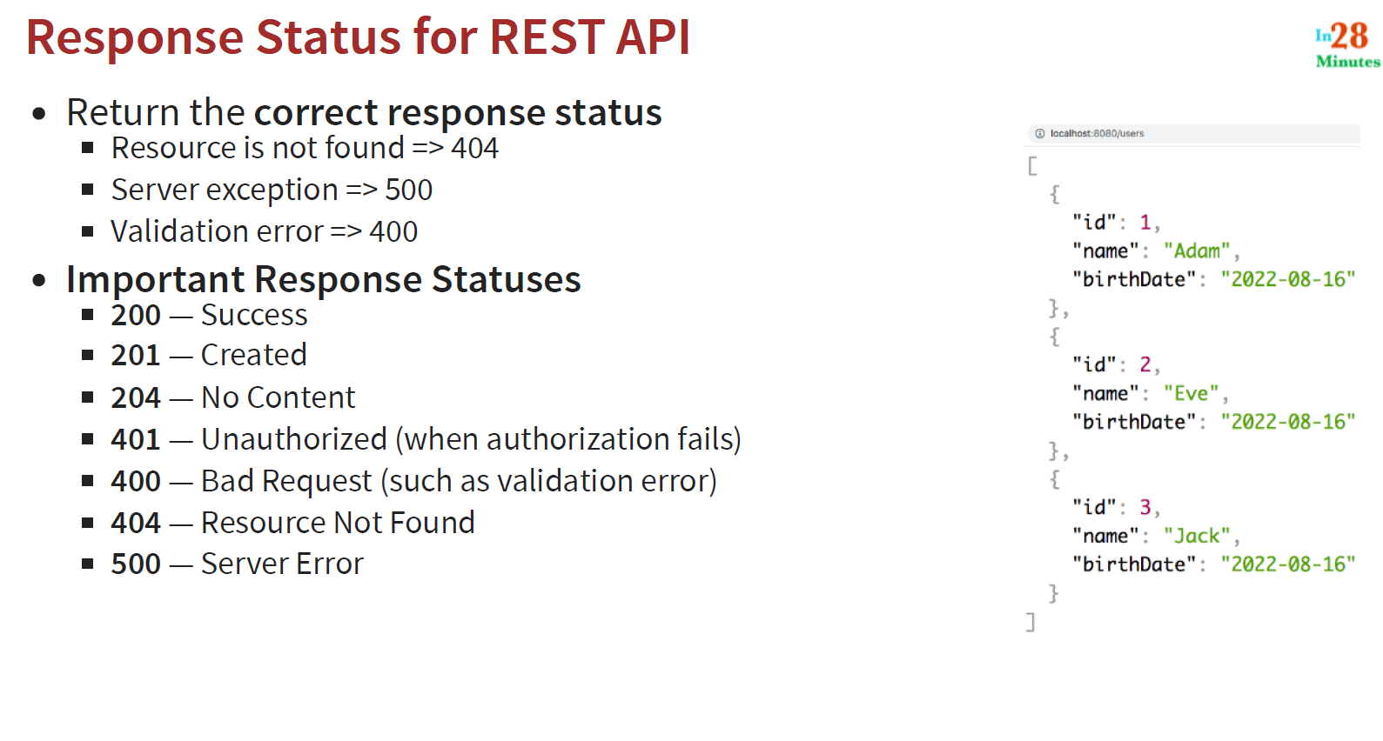
* 201 is correct response status (status code) for successful put request
* ResponseEntity class is used to return response statuses
* ServletUriComponentsBuilder.fromCurrentRequest() gives the the url for the current request
* Whenever we want to return the url of a created resource (e.g. user), we need to a return specific http header called as location
* If a url (or id) is not found, we should return 404 status
* We can use @ResponseStatus(code = HttpStatus.NOT_FOUND) at the class level for exception class to return the appropriate status codes for exception class
* When we run the application in production, it is run as a jar file as a packaged application. Here, in production the spring dev-tools are automatically disabled and hence we won’t get the whole stack trace
* The application is usually run using java –jar (packaged jar file)
* you can also define your own custom structure for request response other than default one which has starcktrace, message, error, status, etc
* This can be done extending ResponseEntityExceptionHandler class
* @ExceptionHandler is used to determine which exceptions to handle
* @ExceptionHandler(Exception.class) means that we are defining this to handle all kinds of exceptions
* @ControllerAdvice is specialization of @Component for classes that declare @ExceptionHandler
* To add validations , add a dependency called as spring-boot-starter-validation
* When we use @Valid annotation, whenever the binding happens (with the object), the validations which are defined on your object are automatically invoked
* These validations are necessary so that user doesn’t enter empty name etc
* The consumers of the api need to know what your apis are doing
* So for this we have Swagger which is used to document our Apis
* 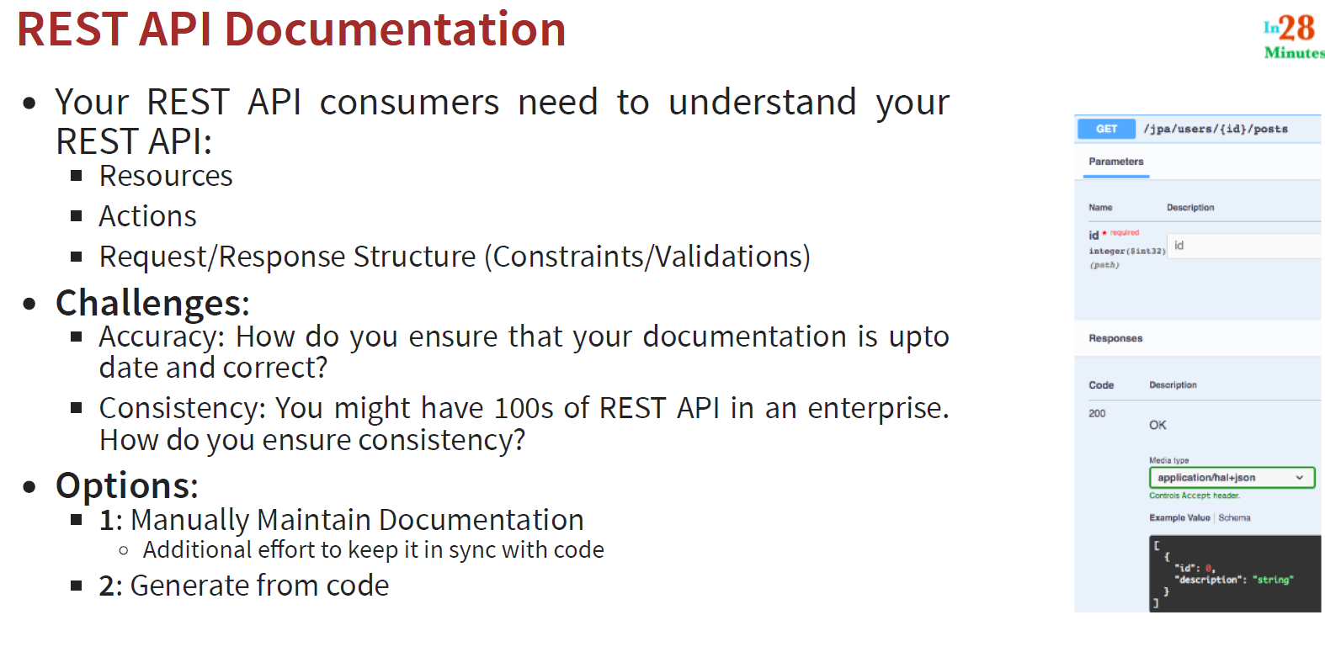
* 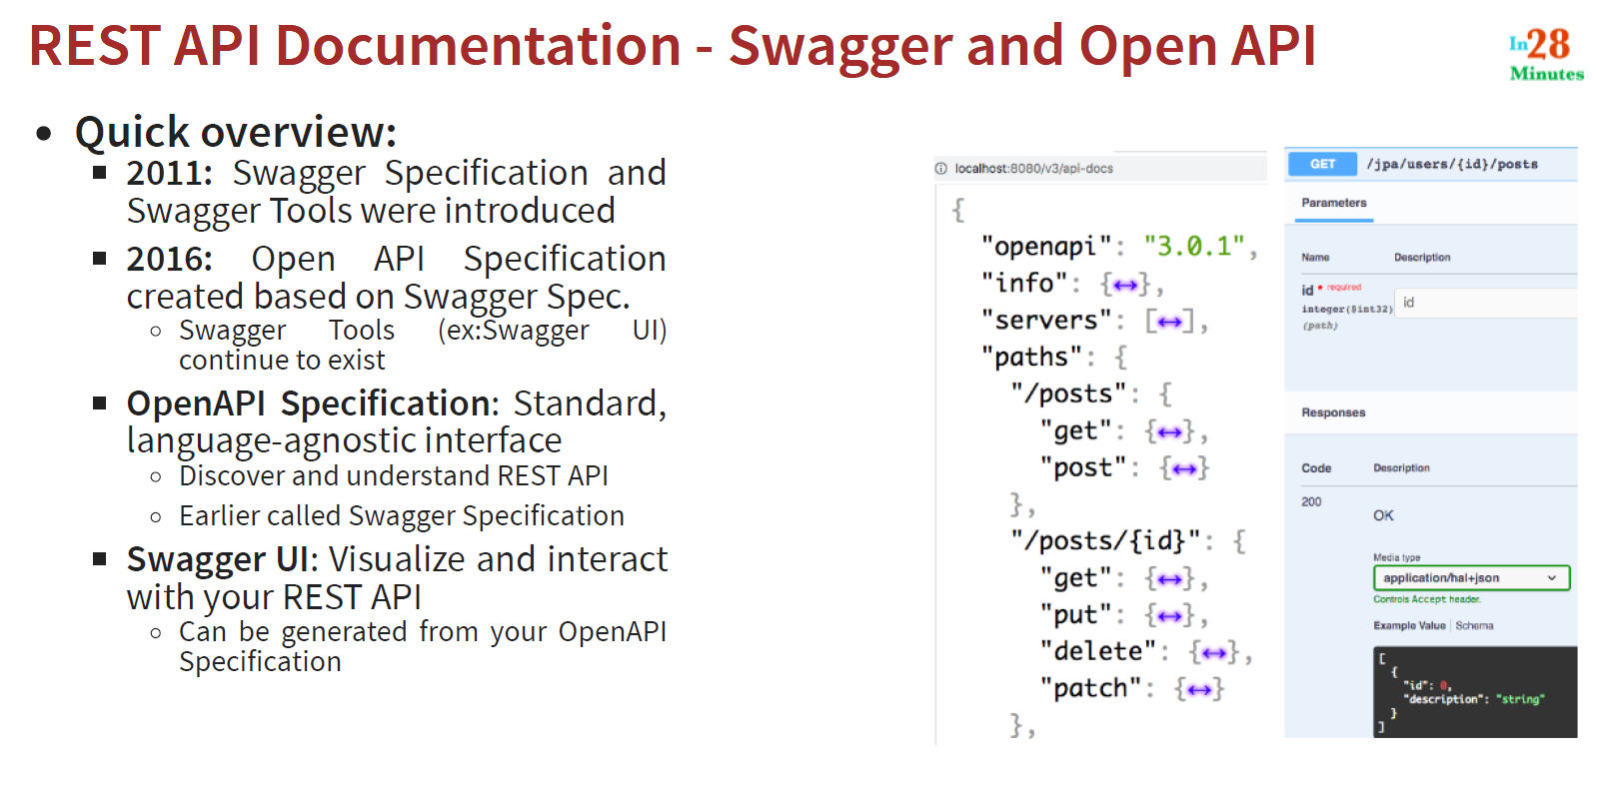
* Springdoc-openapi is a java library used to automate the generation of API documentation using spring boot project s
* To integrate swagger, just add the swagger dependency in pom.xml and go to url: <http://localhost:8080/swagger-ui/index.html>
* In openapi, we define our rest api, operations that can be performed
* Swgger ui provides a nyyc UI for visualizing and trying out the apis
* Content Negotiation: It might be possible that different consumers might expect different responses (json or xml) for the same resources (or url)
* 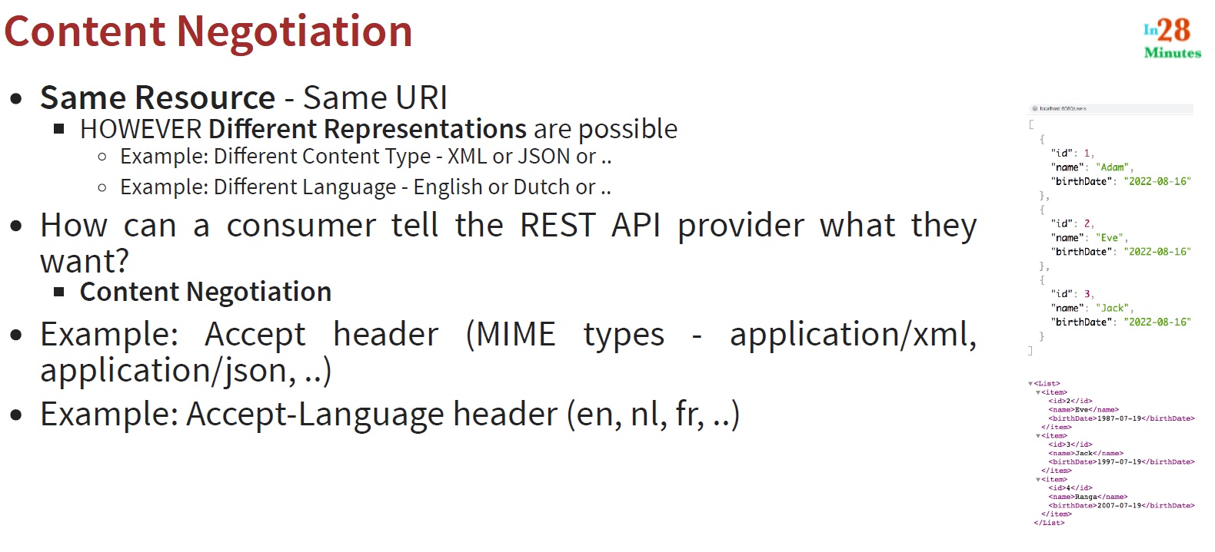
* The consumer and the server negotiate on the response, hence called content negotiation
* This can be achieved using header section of the request
* For this add a dependency in pom.xml
* Internationalization:
* 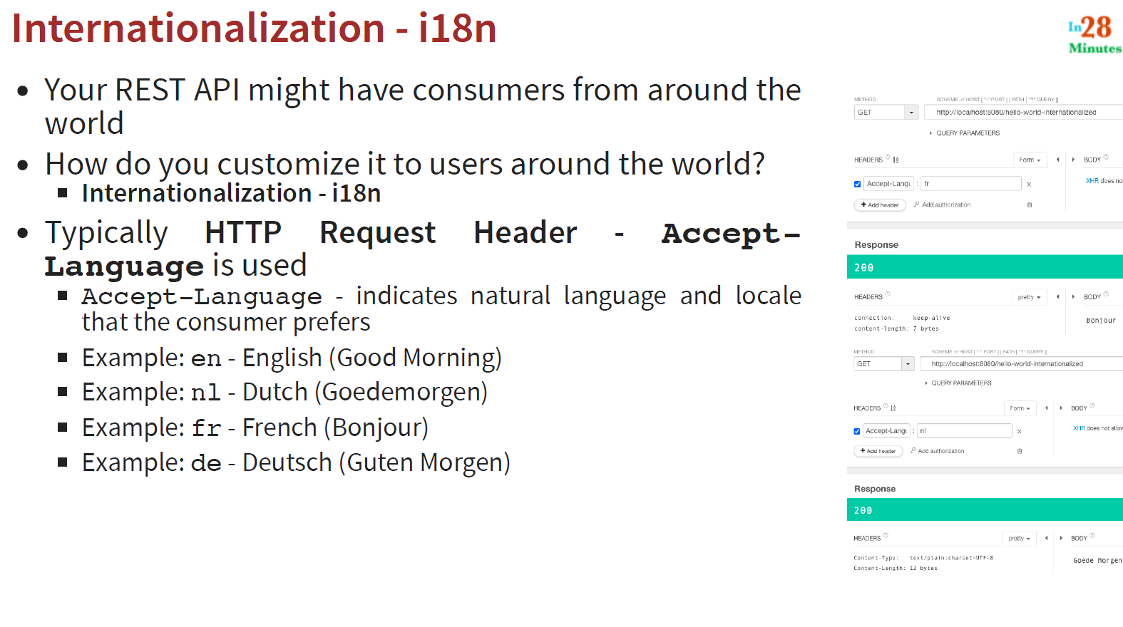
* Versioning of API’s:
* 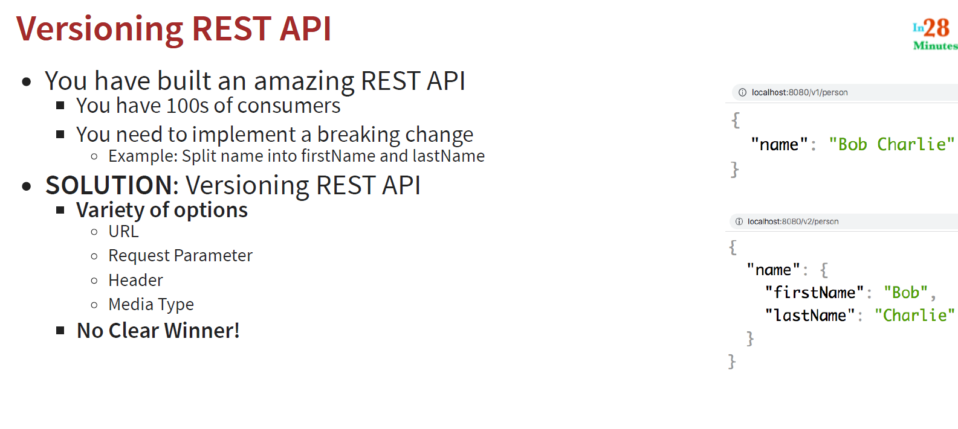
* 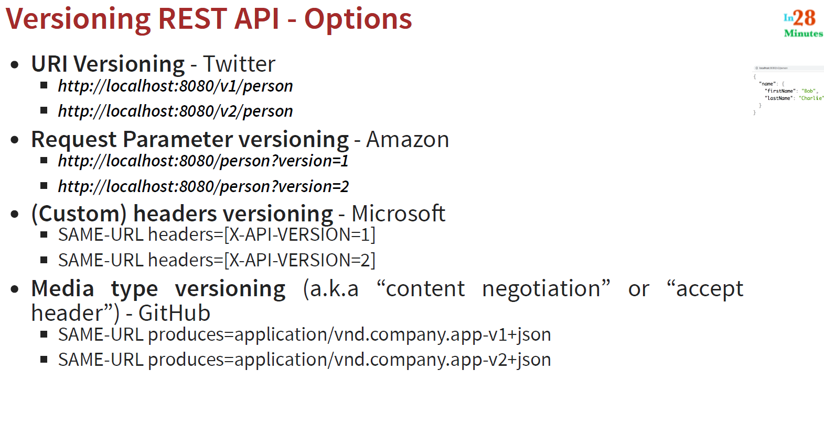
* HATEOAS (Hypermedia as the Engine of Application State)
* 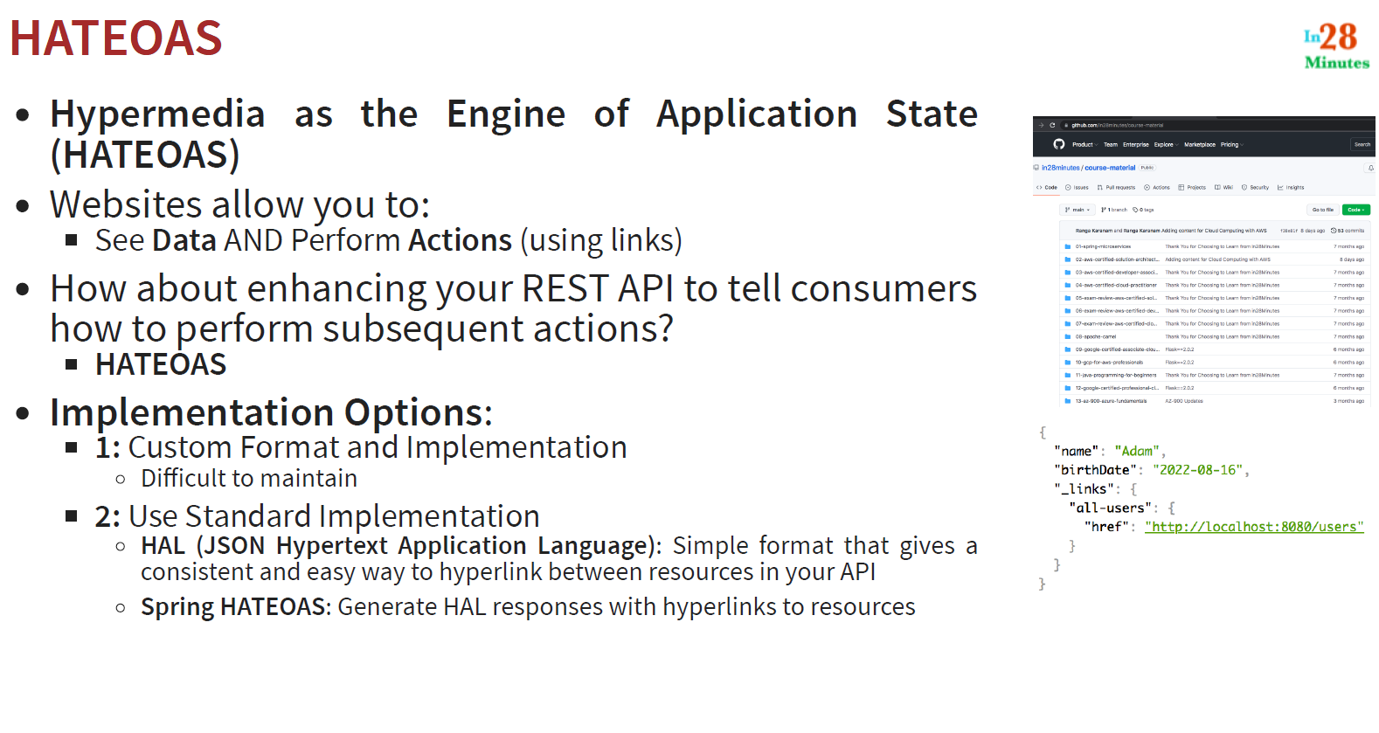
* Add a dependency of spring-boot-starter-hateoas
* Serialization is the process of converting an object to a stream (e.g. json)
* 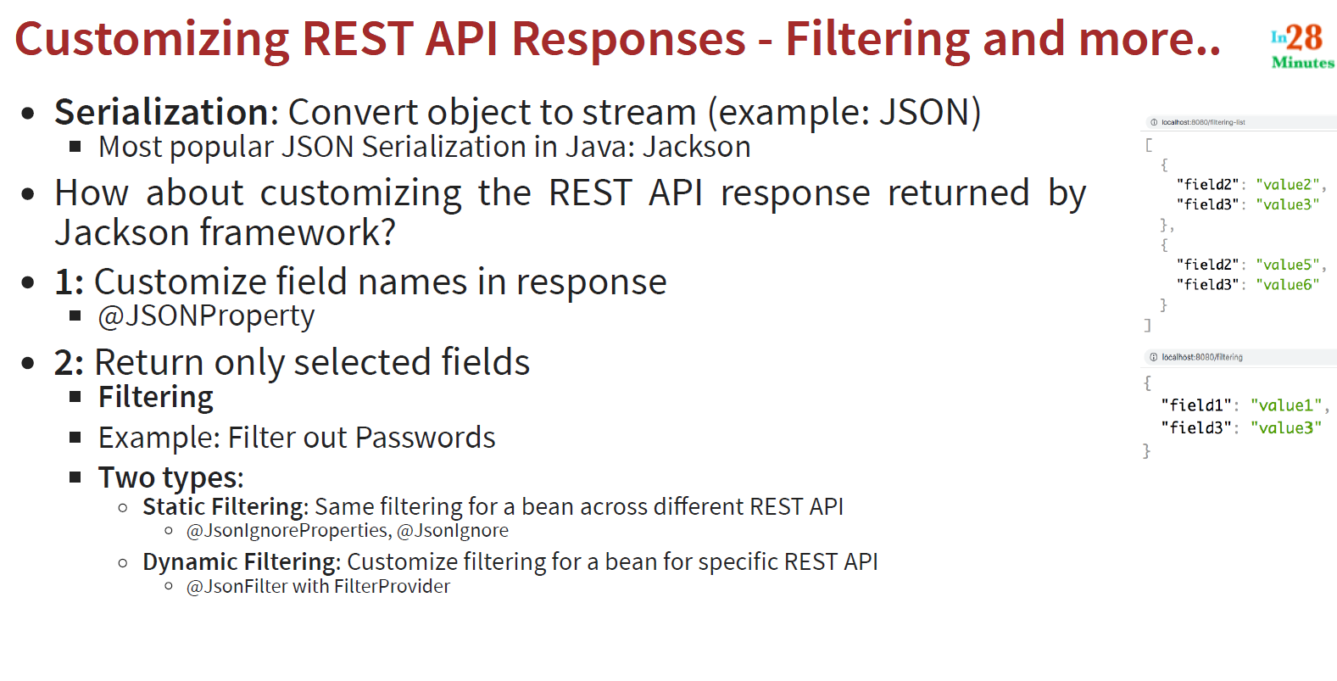
* Sometimes we don’t want to return the exact field names in json, so we can use @JsonProperty to return different field names
* @JsonProperty is very useful to customize the element and attribute names in your response
* Static filtering is same filtering for a bean across different rest apis
* Static Filtering is implemented using below 2 annotations:
* @JsonIgnore allows us to exclude a field as part of the response
* @JsonIgnoreProperties(“field1”) is another annotation used at class level to specify the fields we want to ignore
* @JsonIgnore is preferred over @JosnIgnoreProperties because it works even if the field name changes in future
* Dynamic filtering is used when we to return different attributes for the same bean in different rest apis
* Add spring.h2.console.enabled=true in properties file to enable H2 console
* We can specify the the fetch type of user from posts lazily using *@ManyToOne*(fetch = *FetchType*.LAZY)
* Lazily means it will resolve the dependencies later
* Spring security generates different password each time we start the application
* Hence, we should define our own username and password in properties file using   
  spring.security.user.name=username  
  spring.security.user.password=password
* When the request is made from localhost:3000 to localhost:8080, these requests are called cross origin requests
* By default, cross origin requests are denied
* This is also called CORS configuration request
* 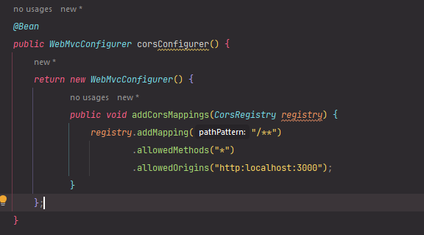
* To allow CORS request, use this above piece of code

Full Stack Applications with Java:

* Node.js is a server side component for javascript
* Npm is the package-manager for javascript
* Package.json file is very similar to the pom.xml as it has all the javascript dependencies
* All dependencies are downloaded in node.modules folder
* React is a javascript framework to build single page appliations (SPA)
* We do not want to refresh the whole page each time we make a change, so, if we want to update just a todo, we can only update that part of the page. This is called a as SPA
* npx create-react-app is used to create react applications
* npm start is used to start the react application
* npm test is used to run unit tests for react
* npm run build is used to build a production deployable unit. This creates a package
* npm install –save Is used to add dependency to a project
* 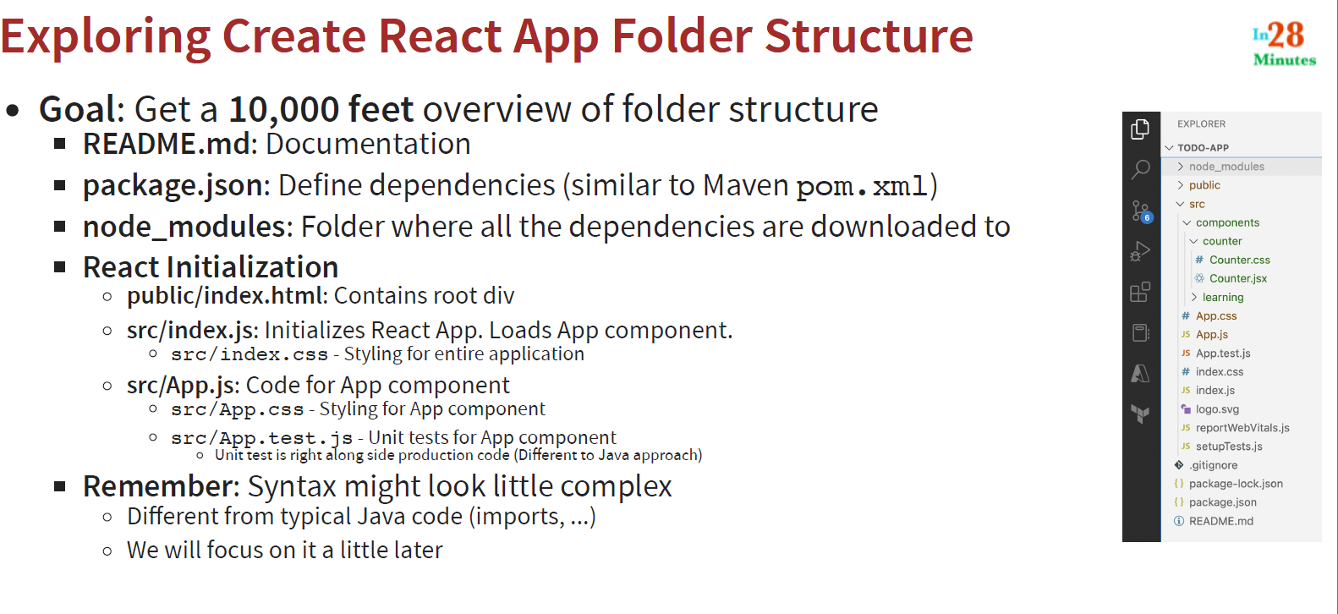
* 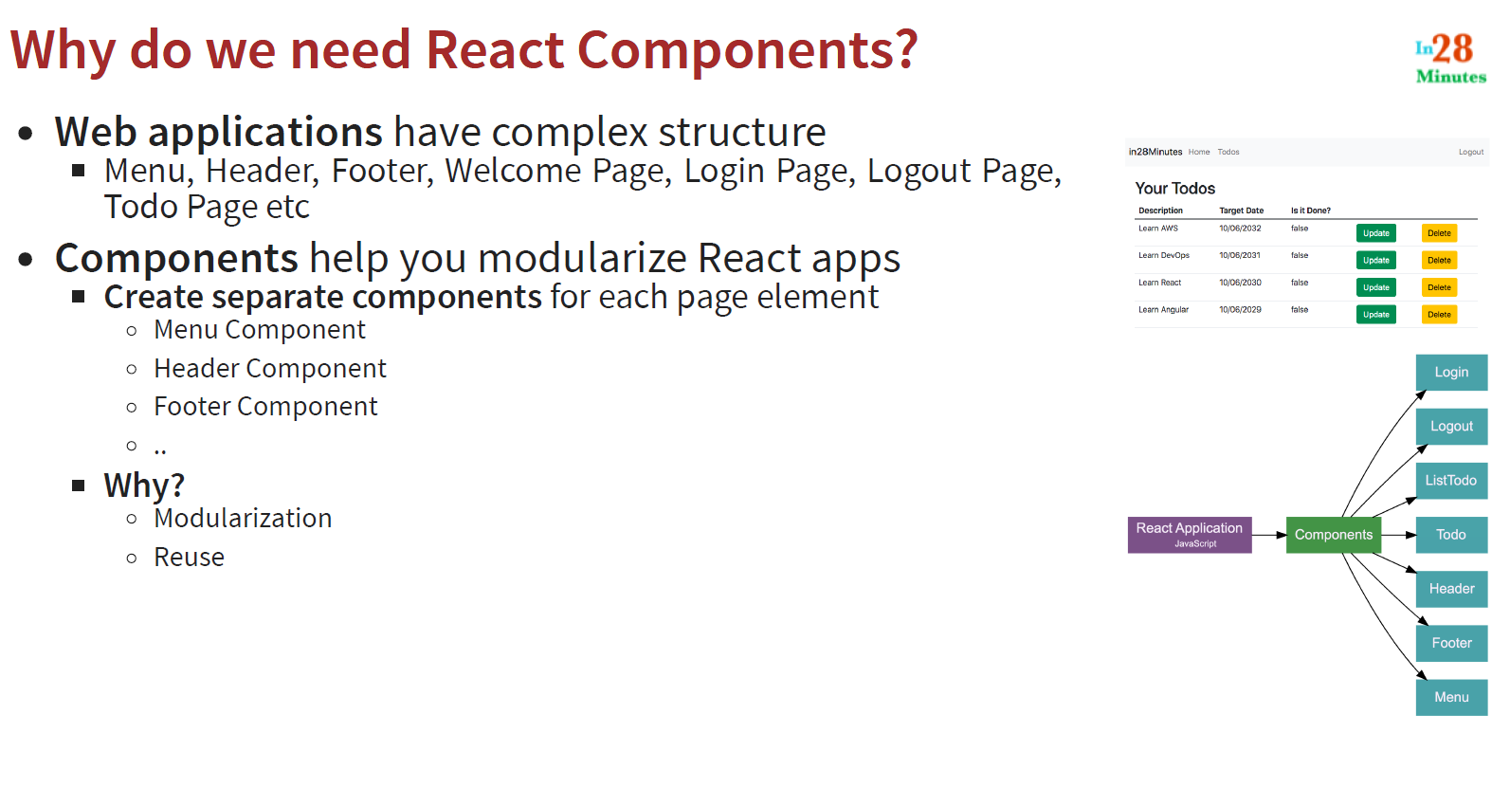
* 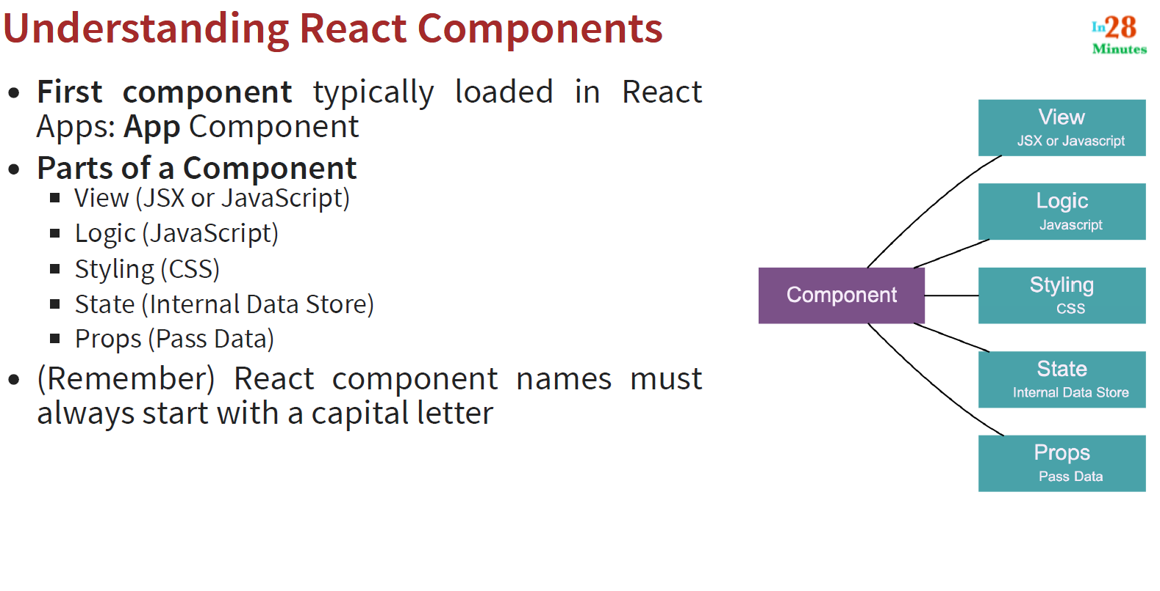
* State in react is nothing but data or information about a specific component
* UseState Hook allows adding state to function components
* UseState returns 2 things:   
   1. current state

2. a function to update state

* Babel is a javascript compiler which allows us to use modern javascript even with older version of browsers. This ensures backward compatibility
* Babel converts jsx into js
* Props are used to pass data between different components
* Each component can be associated with a number of properties
* Props remain constant for the life cycle of a component
* PropTypes are used to accept props of a particular type
* DefaultProps are used to set default value of properties

Unit testing in spring boot:

* In unit testing, we check actual behavior of the app against the expected behavior
* There are 2 ways to test an application:

1. deploy the application and test the whole application. This is called system testing or integration testing  
 2. Test specific units of the code independently like a method or a group of methods. This is called unit testing

* Unit testing makes it easier to debug the code
* We can have a build stage in the CI/CD pipeline which runs all the unit tests and notifies us if any of the tests fail
* In unit testing, we test a particular unit. A unit can be single method, or a group of methods or it can also be a set of classes
* Tests are written in different test package because we don’t want our tests to be part of the bulid (or jar)
* Test files are generally named with convention classnameTest
* It makes easy to find and fix bugs
* Junit is the unit testing framework used in spring boot
* Mockito is a mocking framework
* AssertEquals(expected, actual) methods are required to test using junit
* We need to create instance/object of the class to call the method of the class we want to test. These should be created at class level and not in each method
* @Test annotation is used to mark a method as junit test
* Return type of test methods is always public void. This is because this test method should be able to be called from outside this package
* You can also pass message as another parameter in assertEquals, assertTrue, assertFalse, etc
* AssertArrayEquals() is used to compare arrays (because assertEquals compare objects and not actual values inside array)
* To test exceptions, we can use @Test(expected = NullPoinnterExcpetion.class)
* To check performance, we can use @Test(timeout=1000) (this is in milliseconds)
* Use @RunWith(Parameterized.class) at class level to run parameterized tests
* To run only certain tests in a file, we can organize them into a test group called as test suites
* @SuitClasses({abc.class, def.class}) is annotation for test suites
* If a file contains more than 1 unit test, the there is no guarantee which test will be executed first
* If we want to do something before junit test runs, we can use @BeforeEach on a method. This method will run before each junit test
* Similarly, we have @AfterEach as well
* @BeforeAll and @AfterAll annotations are also present to run before and after all unit tests respectively. These methods should be static
* Applications have multiple layers like business layer, database layer, etc
* To test classes with multiple dependencies, we use stubs or mocks
* Stubs are nothing but classes that implement the interface (data service interface)
* The problem with using stubs is that we need to implement all the methods of the interface even if we don’t need them in our unit test. Also, if we want test for different logic, then we need to create another stub
* Hence, we use mocks
* Mocks allow us to mock a dependency
* DataService dataService = mock(DataService.class) can be used to create a mock for dataService layer
* We need to tell the mock service to return something when some method is called
* When(dataService.retreiveAllData()).thenReturn(new int[] {25, 5, 15});
* This is an example method:
* @Test

Void findGreatetFromAllDataTest() {

DataService dataServiceMock = mock(DataService.class)

when(dataService.retreiveAllData()).thenReturn(new int[] {25, 5, 15});

SomeBusinessImpl businessImpl = new SomeBusinessImpl(dataServiceMock);

AssertEquals(25, businessImpl.findGreatestFromAllData());

}

* To mock List interface, use:
* 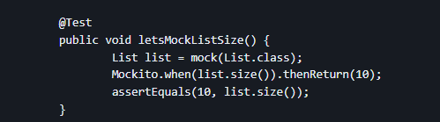
* To return multiple values:
* 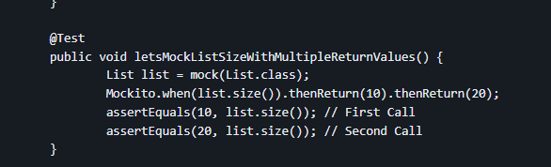
* We can argument matchers like anyInt, etc like this:
* 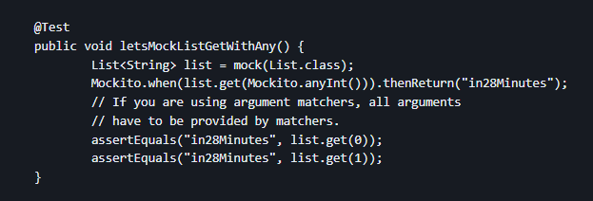
* To throw Exception, we can use .thenThrow()
* Mockito does not allow a combination of argument matchers and hard coded values
* In BDD (Behavior Driven Development), we use given, when then format
* Verify methods in Mockito are used to check whether a method was called or not
* 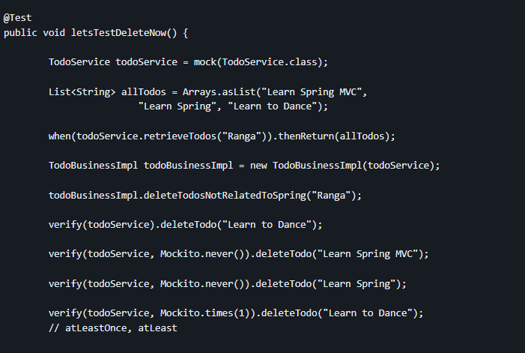
* Hamcrest Matchers allow us to write codes very easily
* 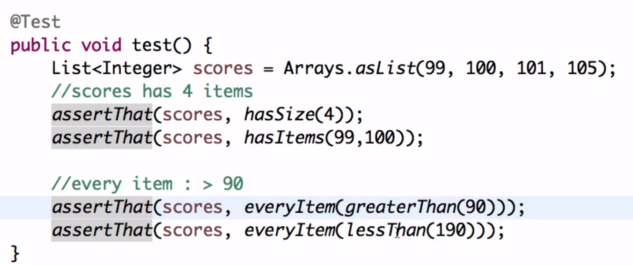
* @Mock is used to mock a dependency
* For this, we need to use @RunWith(MockitoJunitRunner.class)
* @InjectMocks is used to inject all the mocked services to the current class
* We need to mark the class with @ExtendWith(MockitoExtension.class) to use the above annotations
* 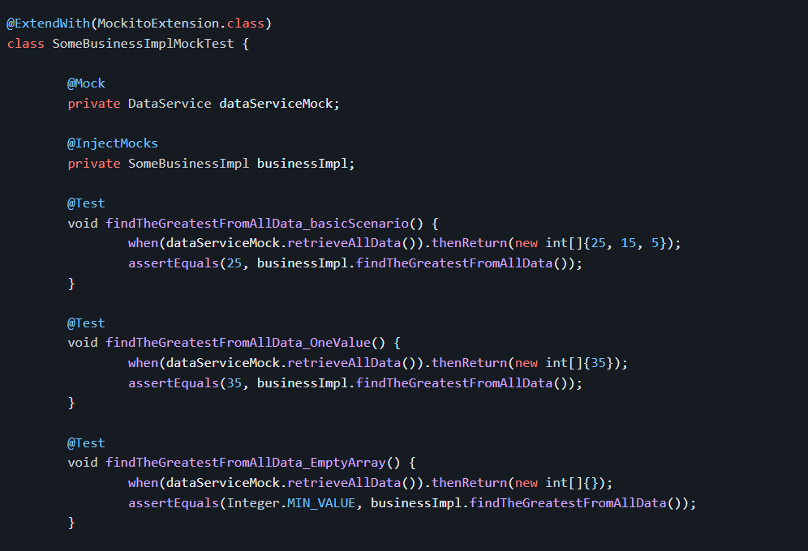
* We can also use multiple .thenReturn()
* The last .thenReturn() will be value obtained at the end
* For writing good unit tests, follow:

1. Name of the test should be readable, (methodName_Condition)  
 2. Test should fail only when there are real logic errors (say your method in the test is talking to a database and the value on the database changes, so the test will start failing ). So, test should not depend on the external database

Spring Security:

* There are 2 basic concepts in spring security: Authorization and Authentication
* Authentication: Is it the right user? (using userid/password)
* Authorization: Does the user have the right access?, access to certain routes and actions. E.g. User xyz can only read data, user abc can read and update data
* Spring Security I used to protect web applications, REST API and microservices
* Spring security has a chain of filters which manages authorization
* 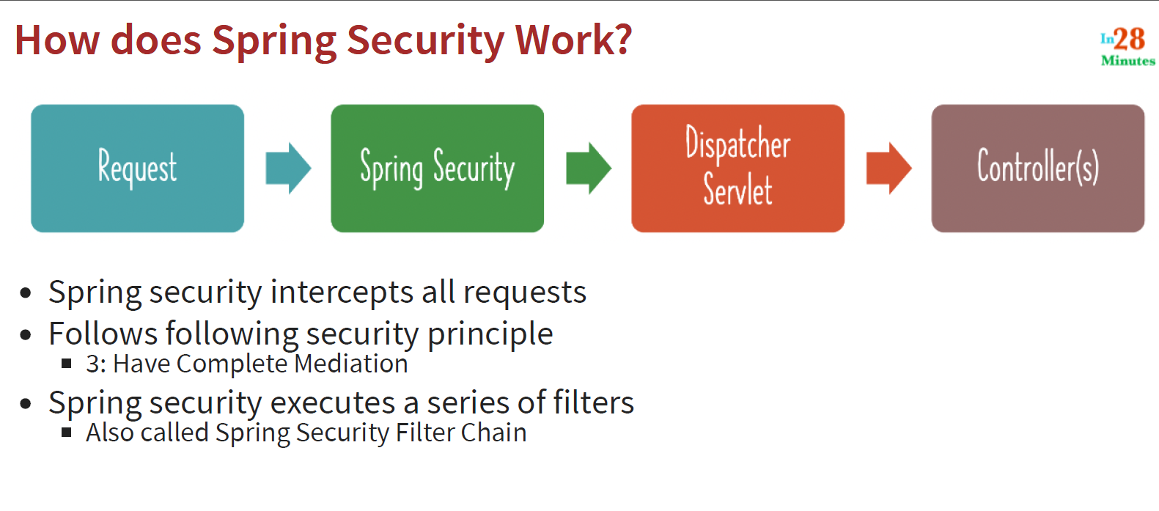
* Every request that comes into your application is intercepted by something called Spring security filter chain which checks for authenticationand authorization and then passes the request to dispatcherservlet and ultimately to the appropriate controller
* Spring Security provides the following features:
* 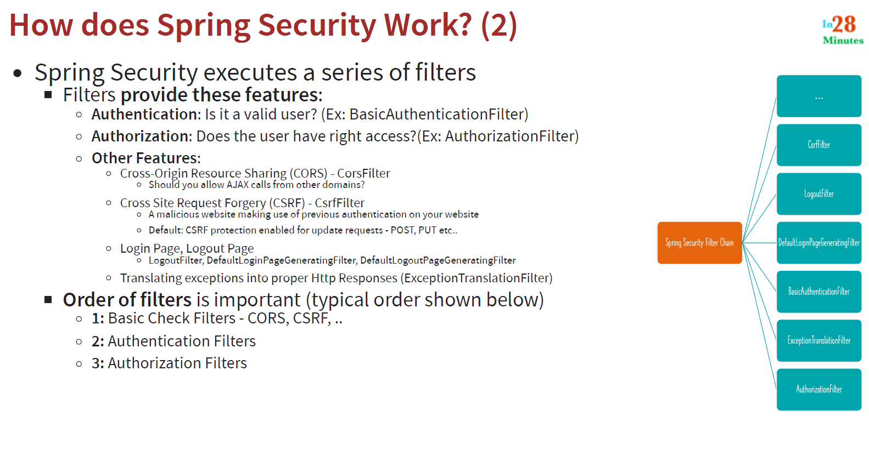
* If you have frontend on one domain and backend on another domain, then your backend should allow requests from frontend. This can be configured via CORS (Cross Origin Resource Sharing)
* Typically, a user session (cookie) is created for you when you login to a website and a user session is identified using a cookie in your browser. If you don’t logout of that specific application, and go to a malicious website, the malicious website can make use of the previous authentication that you have, I.e., the cookie which is present in your browser and use it send/retreieve data from previous website. This vulnerability is called CSRF (Cross Site Request Forgery) .
* When you add Spring Security, CSRF protection is automatically enabled for all the requests
* By default, every request is authenticated by spring security
* It provides a form-based authentication. It provides a default login page
* When the user enters the credentials, a session cookie (or session id) is created which is passed to every subsequent request on the application
* It also provides default logout page
* Spring Boot also provides basic authentication
* Basic Authentication has flaws like the basic authorization header doesn’t contain contain any authorization information. It only contains base 64 encoded username and password
* Basic Authorization Header also doesn’t have an expiry date and hence is available for lifetime
* In order to avoid CSRF, we should use token synchronizer pattern, meaning using new token with each request
* In order to make post/put requests, we need a csrf token
* Csrf token is generated with each request
* You can use this csrf token to pass with headers while making post/put requests
* Csrf is not applicable if there is no session involved (if your rest api is stateless)
* You can also prevent csrf by using something called same site cookie
* This can be done via: server.servlet.session.cookie.same-site=strict
* Cross Origin Request Sharing (CORS):
* 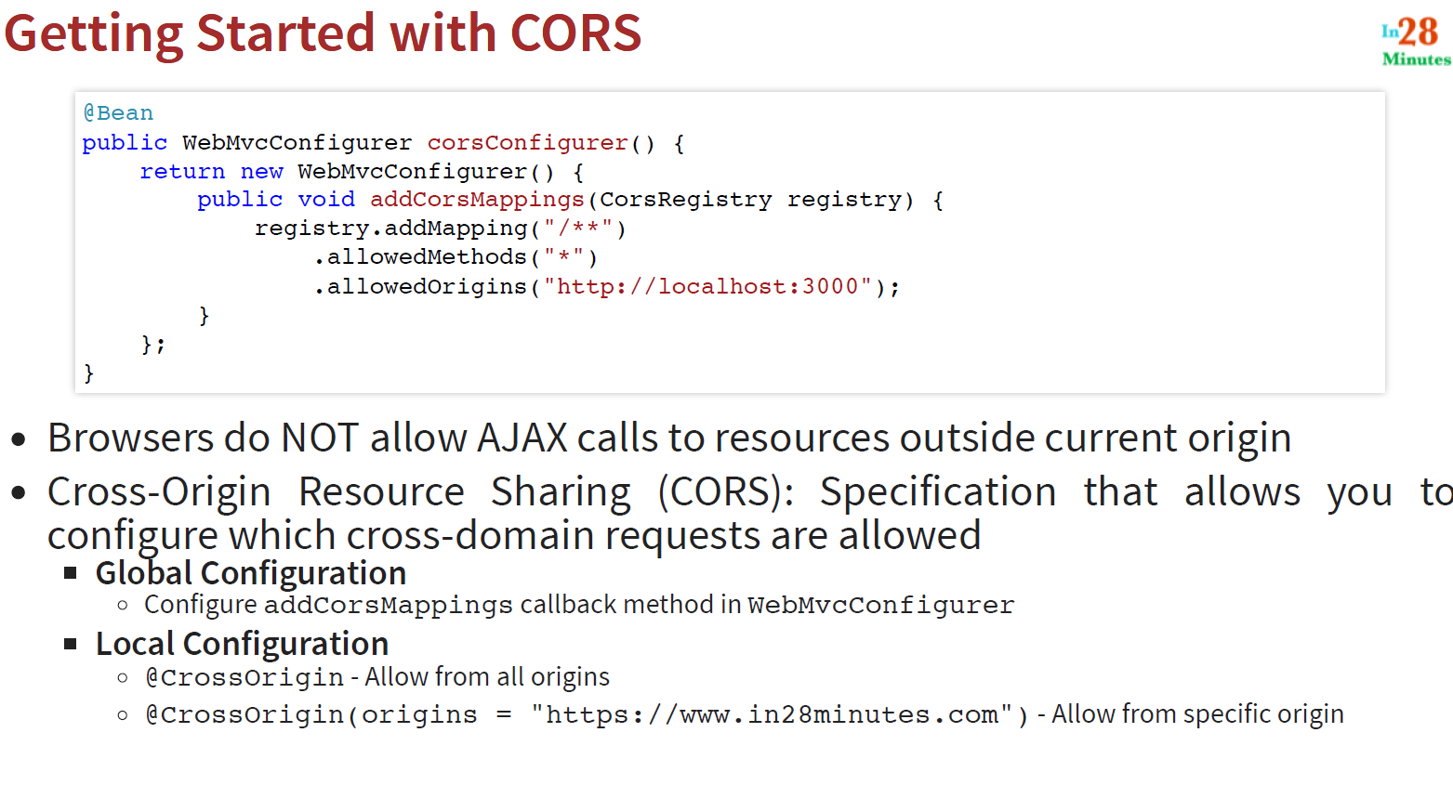
* @CrossOrigin is used to specify from which domain the method accepts the incoming requests
* 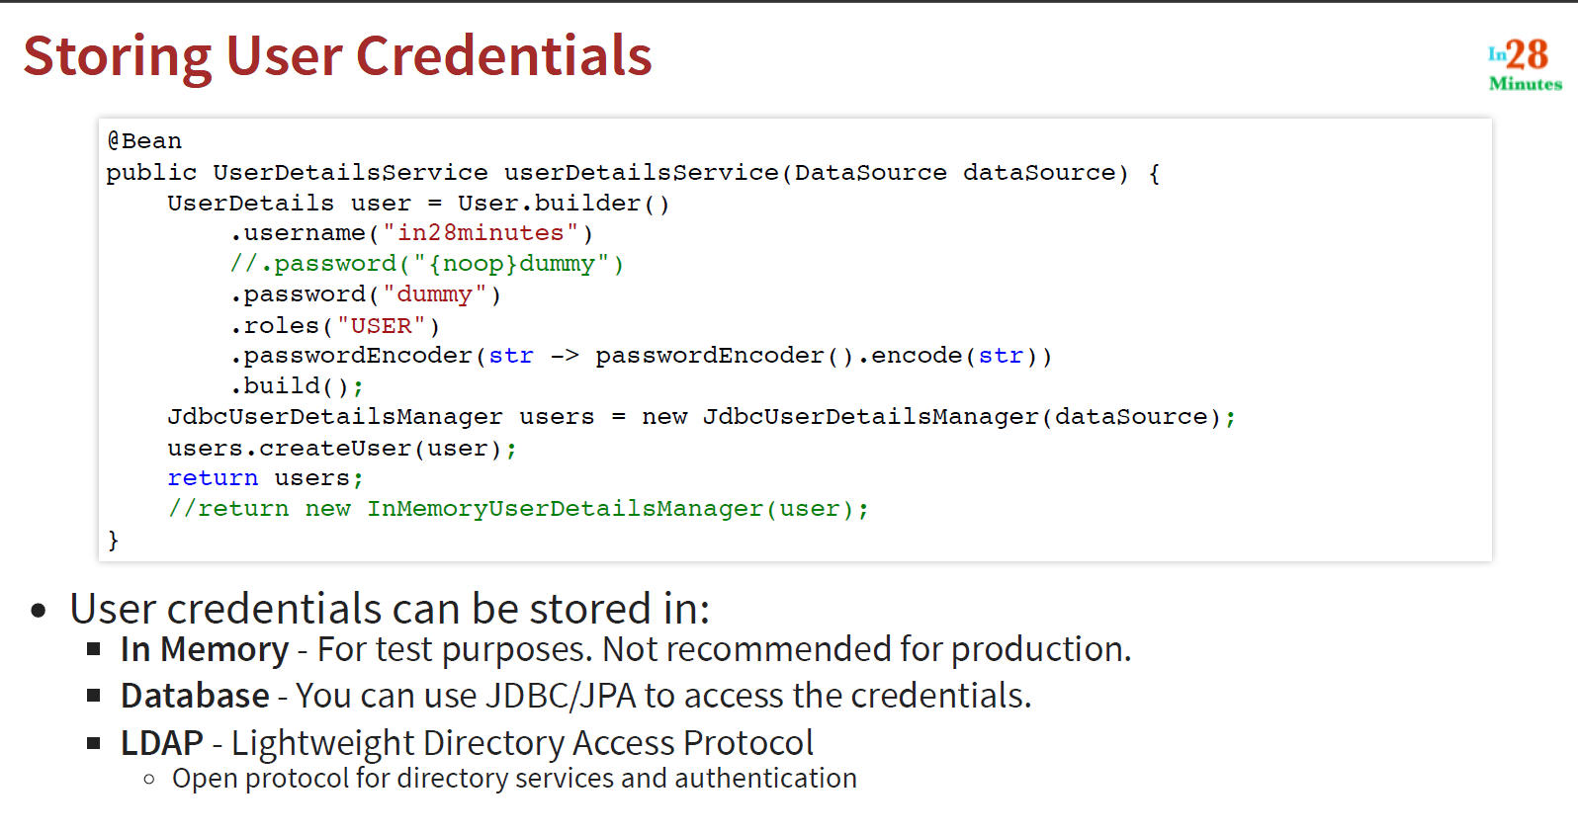d
* We cannot directly store passwords in the db, hence we need to hash it
* BcryptPasswordEncoder can be used to hash passwords
* JWT (Json Web Tokens):
* 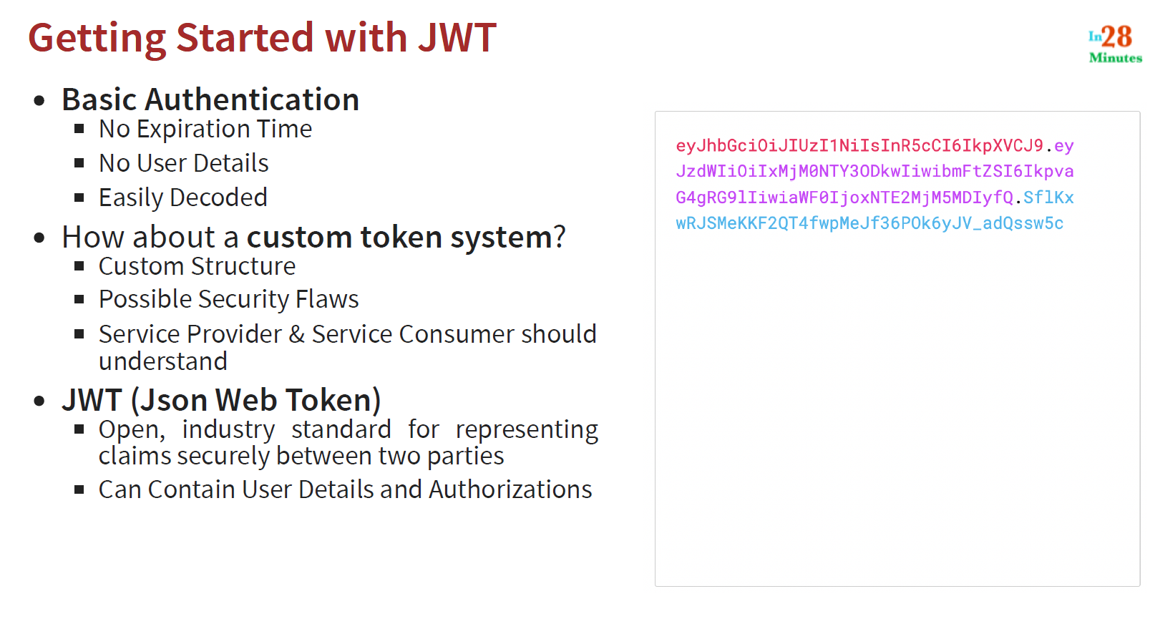
* 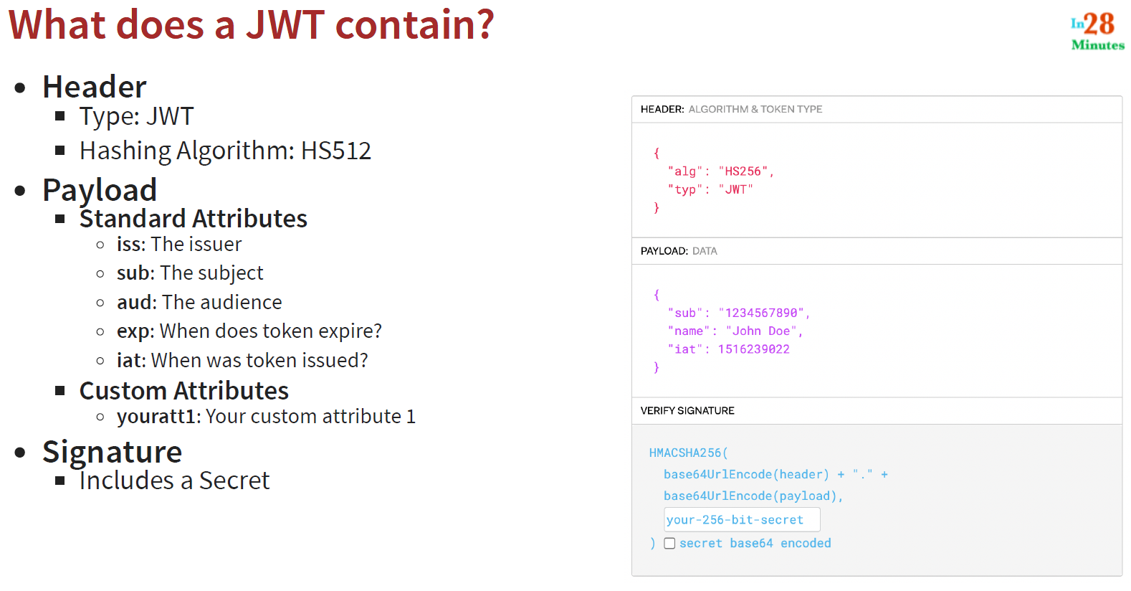
* 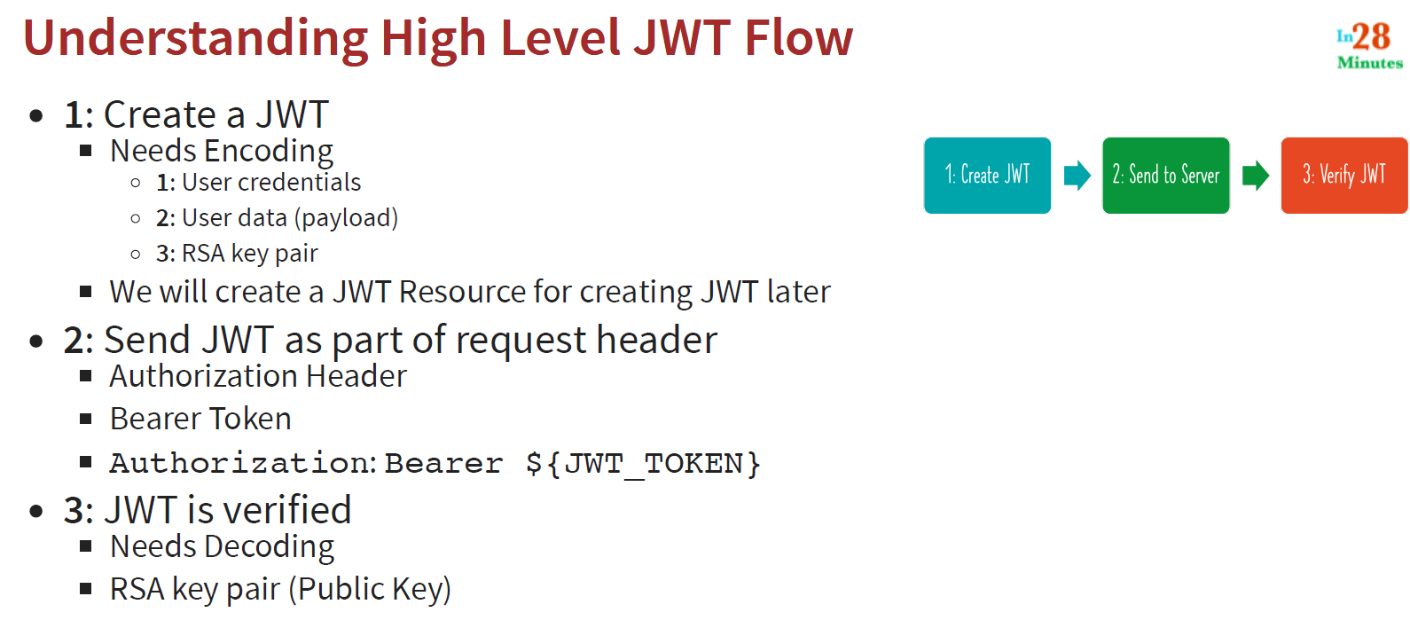

Aspect Oriented Programming (AOP):

* Application is divided into 3 layers: web, business and data layer
* There are things like security, logging, performance which are common across all layers. These are called cross-cutting concerns
* AOP allows us to implement cross cutting concerns
* We define an aspect (like logging, security, etc) and define a point cut to determine to which layer this aspect should be applied

Maven:

* It is a build tool which is used to compile, build and test your application
* Pom.xml is the file which contains all your dependencies
* These dependencies pull a lot of jar files for the application
* These dependencies also have some dependencies which are called transitive dependencies
* Dependencies are nothing but libraries and frameworks used in our project
* We specify group id and artifact id for our application, so, if any other project wants to use our application, they can add a dependency in their project using group and artifact id
* We can push our project to maven repository so other projects can use them in their own projects
* Maven build lifecycle is a sequence of the following steps: validate -> compile -> test -> package (or creating jar file) -> integration test -> verify tests -> put jar file in install folder -> deploy
* Dependencies are installed from maven central repository and stored in the local temp repository

Gradle:

* Gradle is used to build, automate and deliver better software
* Gradle is a platform independent tool, I.e., it can be used to build any application be it C++, Java etc whereas maven depends on java.
* Gradle is faster as it only builds files that are changed; hence, it uses incremental build
* All dependencies are defined build.gradle
* Settings.gradle is the file in which our project name, etc are configured
* Java plugin in build.gradle is used to compile and test java code and build jar files
* You can add tasks in gradle and run them as part of your build

Docker:

* 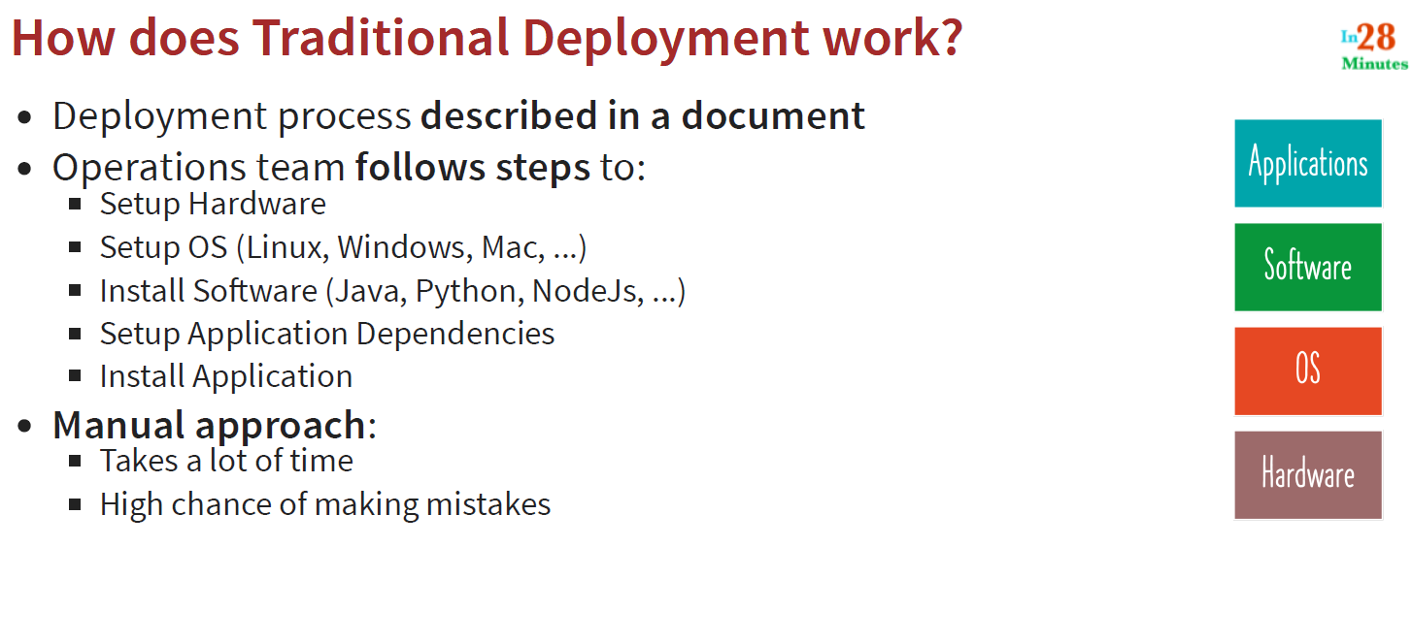
* docker --version is used to check docker version
* Docker allows us to create docker image which can be used to run the application from any machine in any OS and any language
* 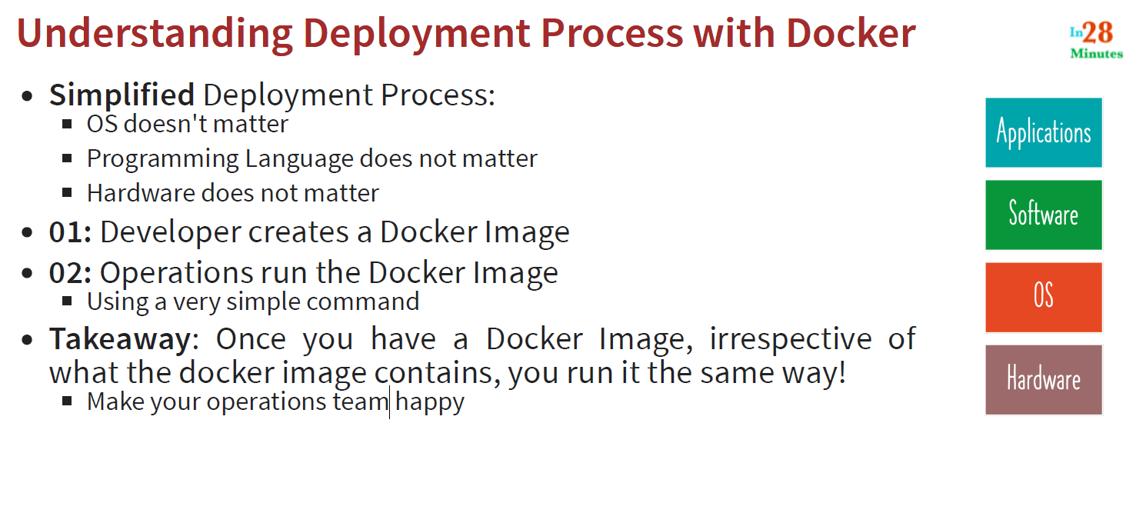
* Irrespective of what is in the docker image, we can run it the same way, be it python , java or nodejs application
* 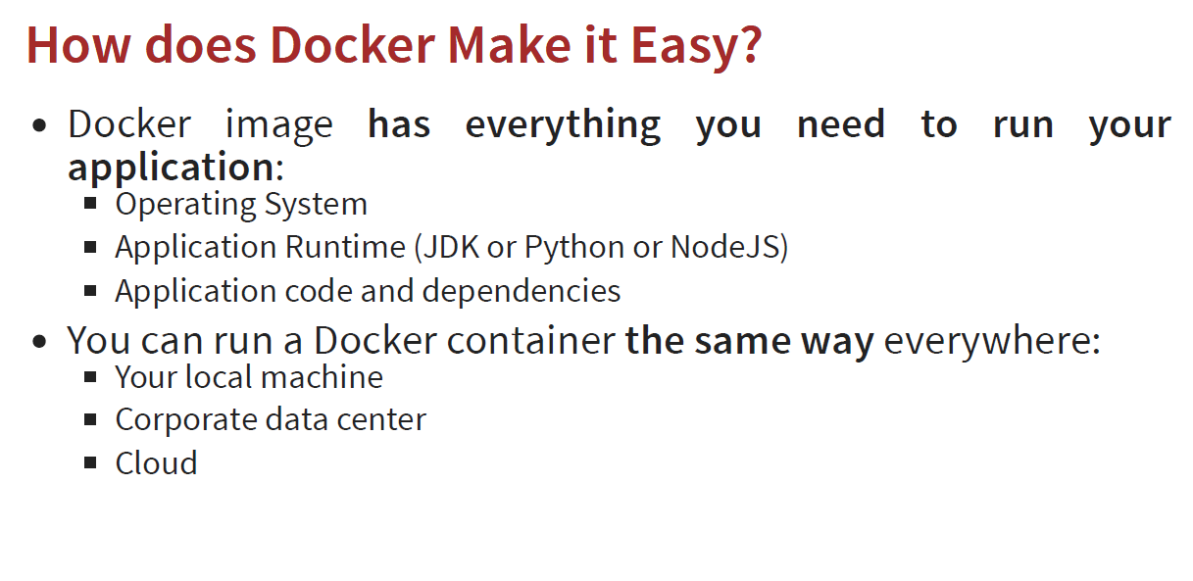
* Docker allows us to have a standard way of packaging. It allows us to create a docker image which contains the same packaging for all types of applications (java/python/nodejs). Docker image is platform independent, ie, it can run on local machine, data center or cloud
* Each docker container is independent of each other
* Even if you have multiple containers running on the same machine, each container is isolated from the other containers
* 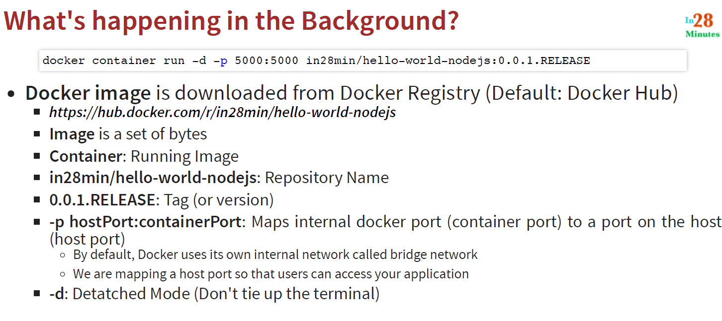
* 0.0.1.RELEASE is the version , called as tag name
* 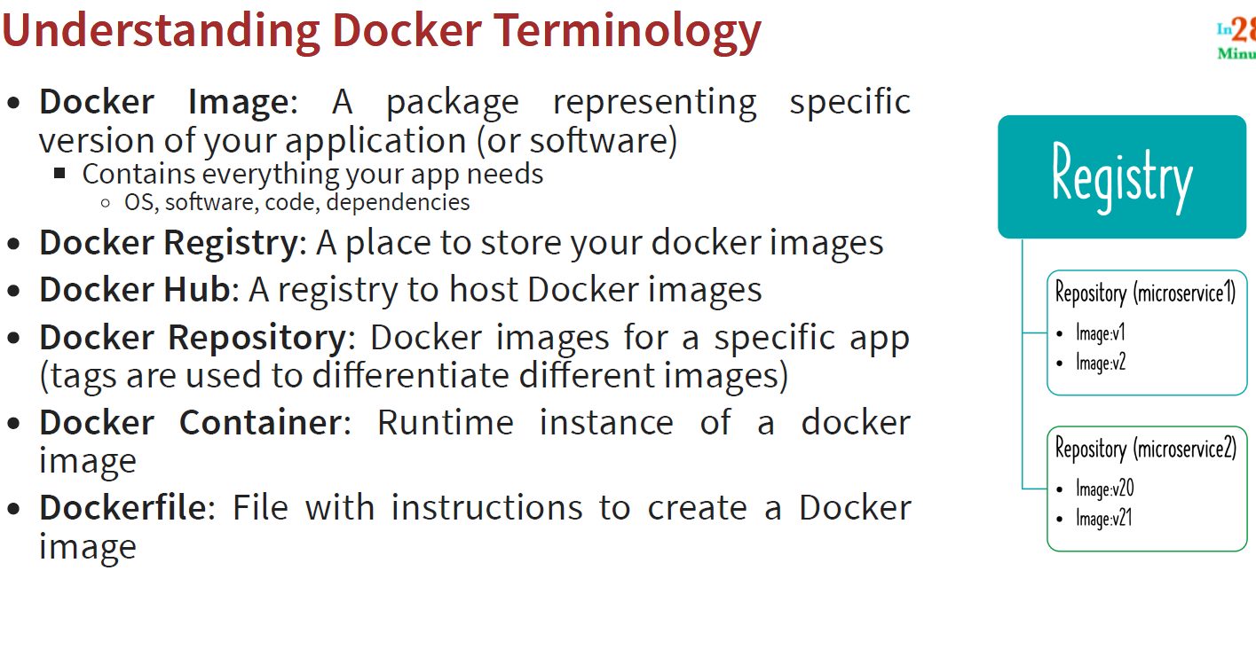
* When we create a spring boot project, the application jar is created in the target folder
* To create a docker image, create a file in root folder called as Dockerfile (same syntax) and add the below steps
* Every docker image starts from a base image
* 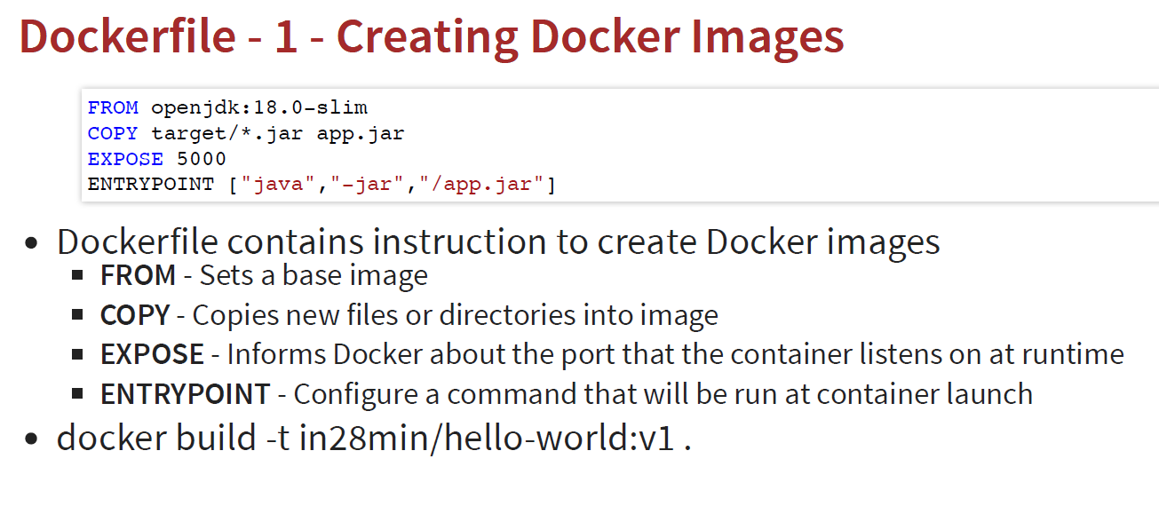
* Generally, it is not recommended to build your jar locally and add it to docker image as it might not work (or produce some other ouput) on different machine. Hence, it is recommended to build everything inside the docker image
* 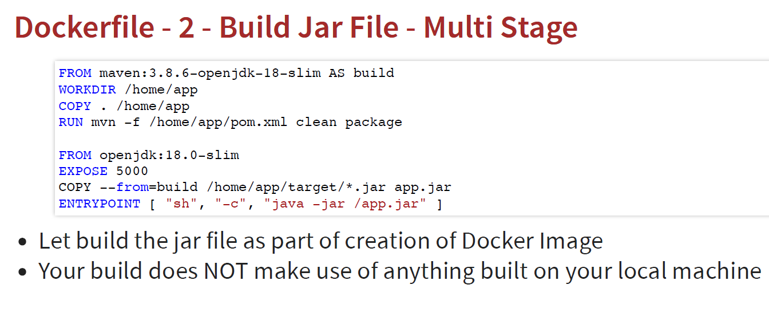
* In this, we are building the jar file inside docker image
* The build takes a lot of time, so, we can optimize this further
* 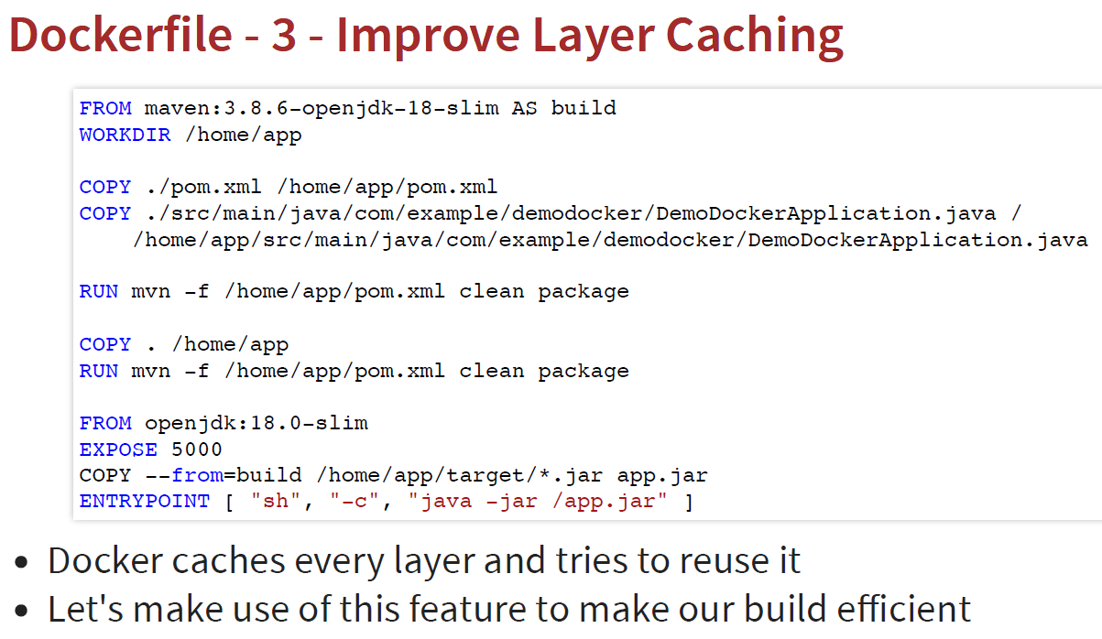
* In this approach, if there are no changes in pom.xml and root file, then these layers will be cached and won’t run again
* We can also create docker images using spring boot maven plugin
* 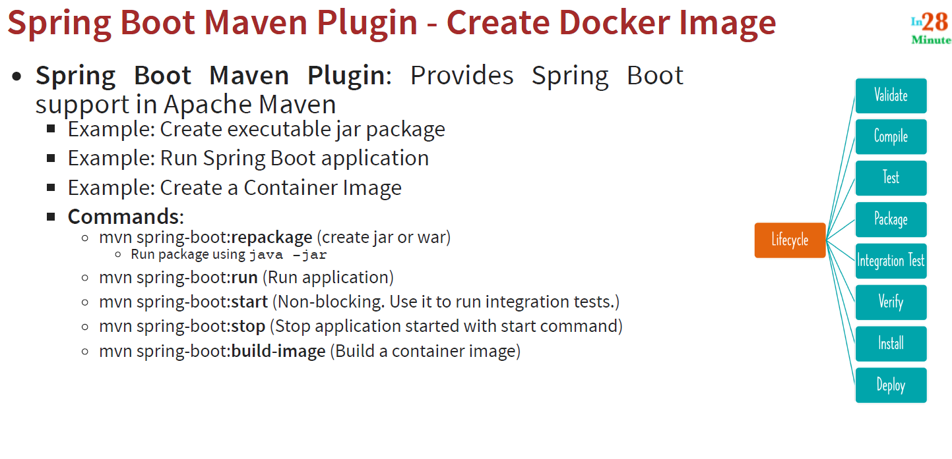

Cloud and AWS:

* As load varies, the infrastructure to handle load also varies
* With cloud, we don’t buy resources, we rent resources
* 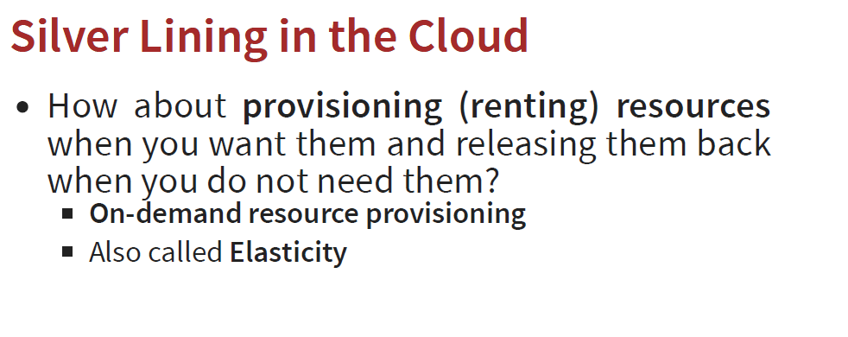
* Each cloud provider has millions of servers
* With cloud we can deploy our application to multiple parts of the world
* It's difficult to setup reliable databases, cloud makes it easy for us by avoiding undifferentiated heavy lifting
* We don’t need data centers anymore
* AWS is the leading cloud service provider (Netflix,Facebook, Amaozn, Airbnb uses AWS)
* EC2 (Elastic Compute Cloud)
* In AWS, EC2 instances are virtual machines
* The service used to provision EC2 instances is called EC2 service or simply EC2
* We can create and manage lifecycle of EC2 instances, attach storage , load balancing using EC2
* Infrastructure as a Service (IAAS): In iaas, we are responsible for everything,
* 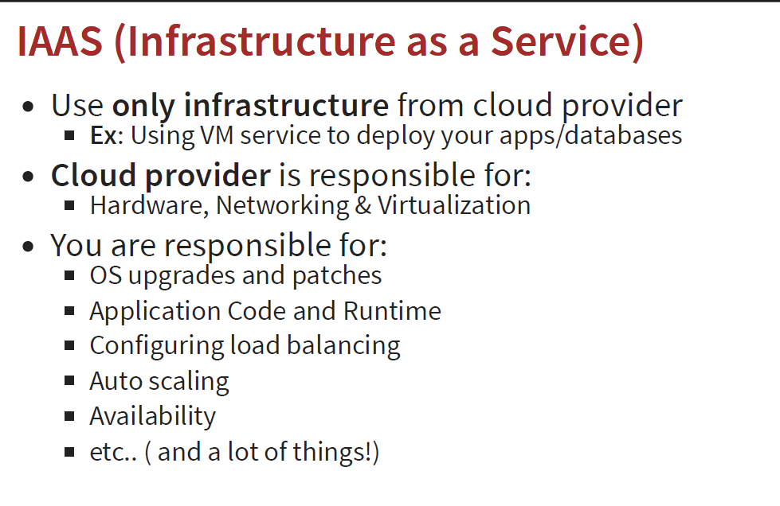
* To give some of these responsibilities to the cloud service, we use Paas (Platform as a service)
* 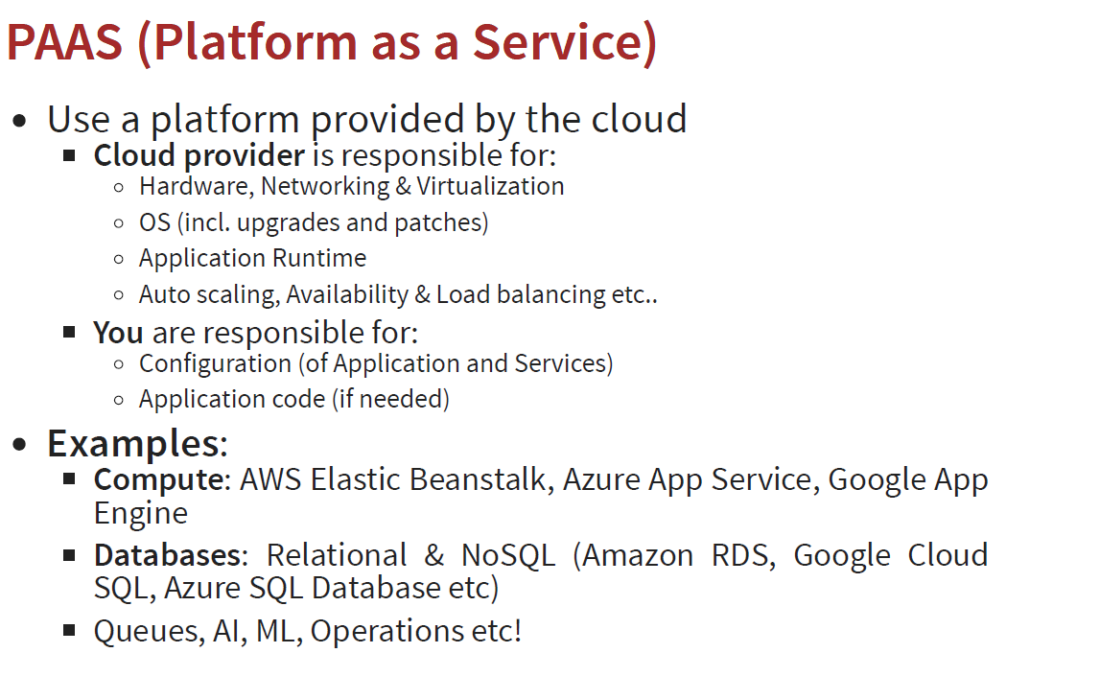
* Paas is preferred
* AWS BeanStalk is the platform as a service offering in AWS for running your compute workloads
* 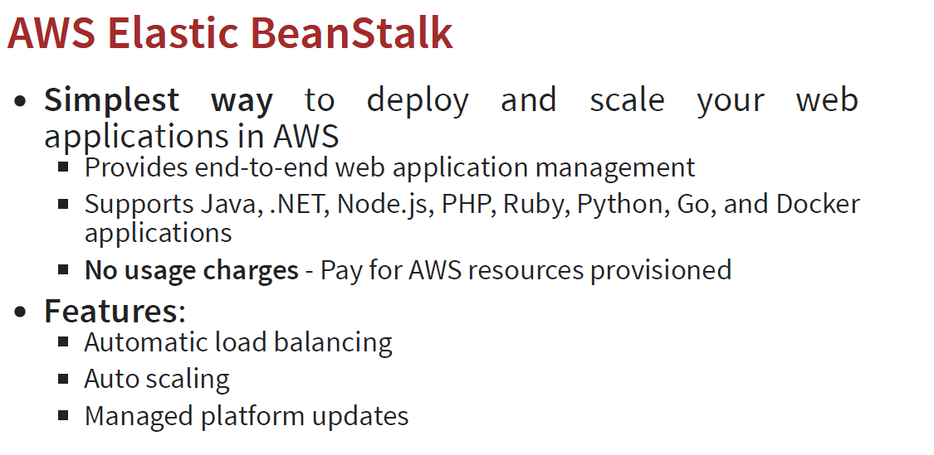
* 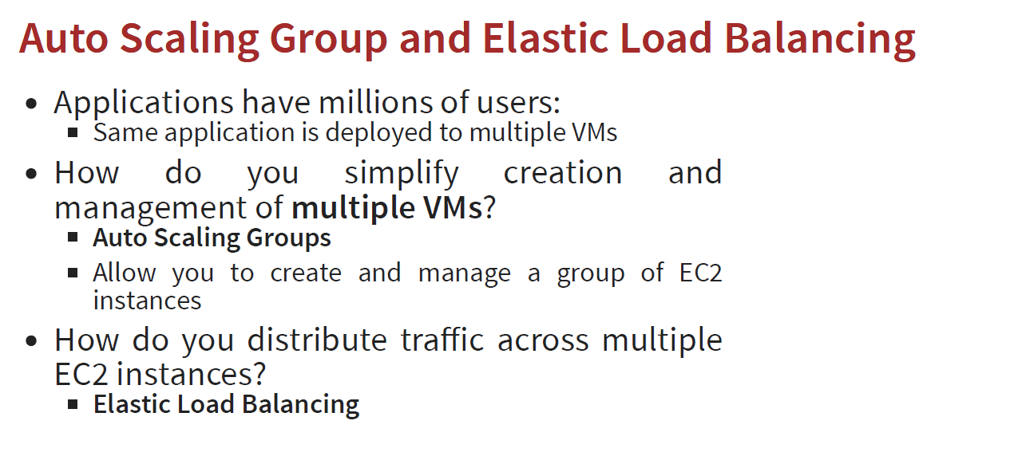
* Depending upon the load on your application, we can use auto scaling groups to manage a group of EC2 instances together
* AWS Beanstalk is Paas which offers auto scaling groups as well as elastic load balancing between different ec2 instances
* Microservices refers to building small independently deployable services
* We deploy these services on AWS/cloud using docker images
* Docker is cloud neutral
* 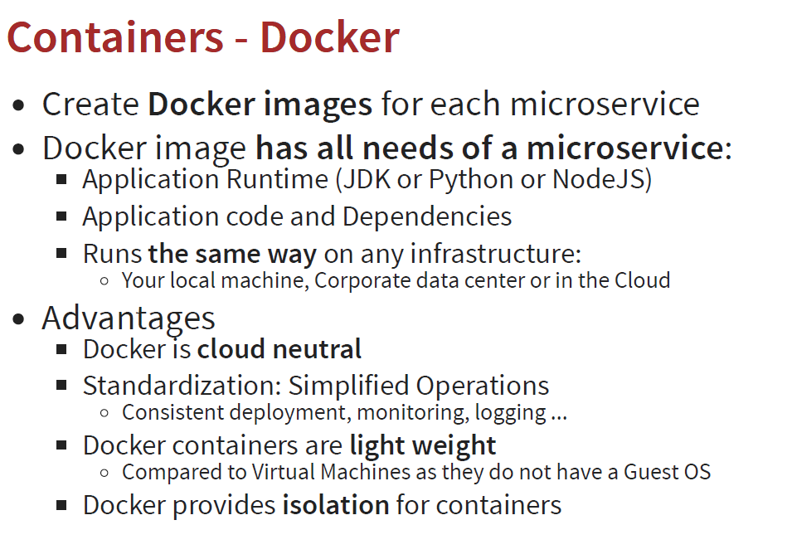
* We don’t want hardcode the url of one service in another service in order for them to communicate. This should happen dynamically. This is called service Discovery
* 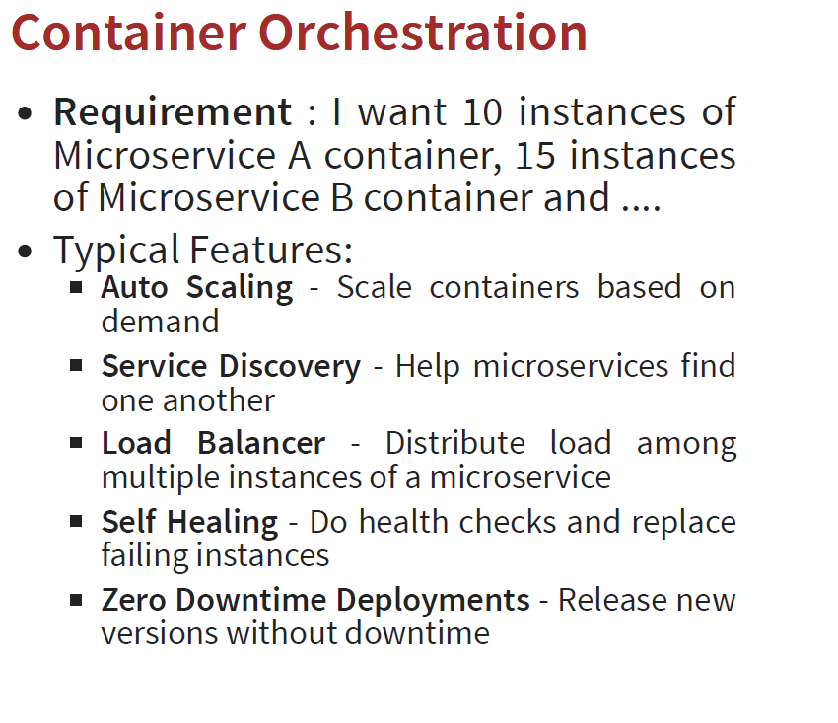
* With Container Orchestrator, we can form a cluster of EC2 instances or virtual machines to handle all the instances of different services. We can use thsi tool to deploy the microservices to the cluster
* You can provide the container image and the configuration to the container orchestrator, and it would deploy the microservice to the cluster
* Kubernetes is one of the container orchestrator
* 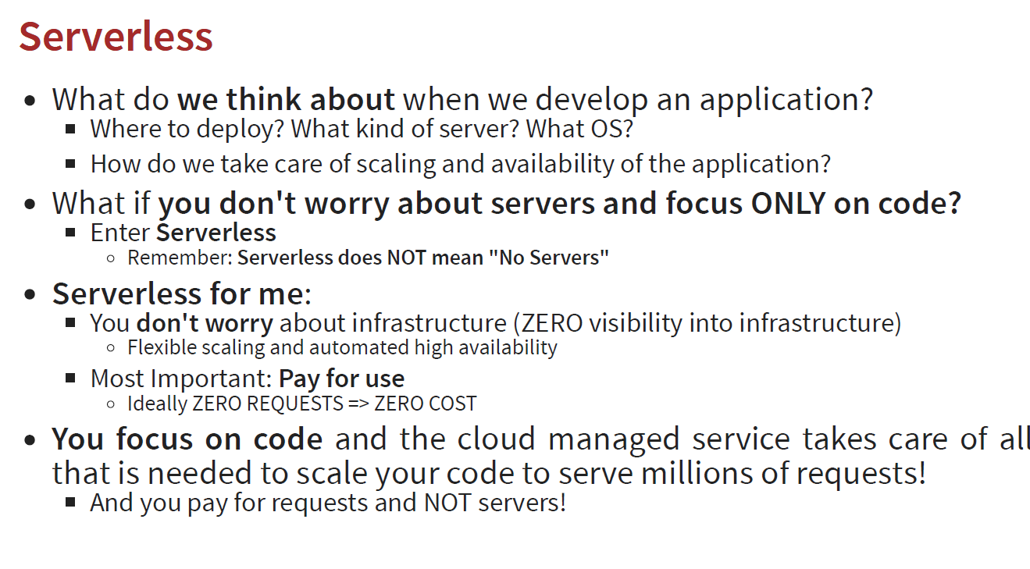
* AWS lambda is a serverless service
* In Serverless, we pay for requests
* Amazon S3 is used to deploy static frontend applications

Topics to study:

* Functional interface/lambda expressions
* streams
* Localdate vs date in java
* How does executorService handle race conditions
* Junit and mockito
* Jpa and hibernate
* Different types of logging
* Spring Security
* Cloud and aws